'>l'i <j'f
<1't 91fw!
<El
'[<'IT 13 91fw! "It
91fw!
- 9/<El, Gll'>!TTf 13, 1't<!ll-:i o9
www.bbs.gov.bd

<ll') : o 8 '[<'IT (Consumer Price Index-CPI) <El<! 1<11 N>
(Inflation Rate) <El'mi'f Pr N9t

<j'f 91fw! (AA<El ) <El'i'f G!Tl3 <EJffif.t 9f<ITT!
a<rr 13 Q'rffi! (Goods & Services) '[<'IT "fR> 15 'i <l>G '[<'IT
)J_641->i)J_ ( , 9@, ) <£1<1 1'1l/4ilN5 "ffi.l I )J_64'->i1 <£1<1 )J_<1)/4ilN5 'i,
$I<TEl<! $IT (General, Food and Non-Food) <El 1%r! '5tt '51l0Wil lc<I "fR> <T '51•.JPll"i-1.Q>C <I'm I f%fu o :i- = :ioo '[<'IT 13 1<11/4ilfi:b nf ROI <!"Flt 15 91-1 <Pm WIT:

fcl |  | oo(!-ol!, = ::,oo |  |  | o ::,- = ::,oo
 |  | o | o | o | 0 ¢ | 0 ¢ | 0 8 | o B
 |  |  | ,!) | 8 | 4 | I!, |  | l,
Jjflj8"of |  | ;,;,",::,;,;, | "::,",91!, | "::,a.::," | ::,::, .81!, | ::,::, .b-?i> | ::, "·"\,- | ::, l!,.ol!,
Jjflj8"of | Re-Reference Index | ?i><!.% | ::,o .89 | ::,o .?i> | - | -  -"" | - | -
Jjflj8"of | '1/."lfl (flf'GFt;..!-9faFl;J | <l'."I!, | '\.<l'I!, | '\.Slr | .'18 |  | -'1 | .1.!,I.!,
Jjflj8"of | '1/."lfl | o.a::, | ::,.s<t | o.88 | - "" | o. | - | - '1
 |  | '-'::,l!,,O | "So.Sb- | "s::,.;,;,::, | ::,::, . (! | ::,::, .98 | ::, ".?i>8 | ::, b-.1!,8
 | Re-Reference Index | ?i>8.?i>8 | ::,o . ;,;, | ::,o .9 | - | - | - | -
 | 'f.'1}(9faFll-f-9falit;J | <l'.O\r | "'·"'\ | 1r.::,;,;, | - '1 | .% | o.8 | 8. 0
 | "J.'71 | o.<l'lr | ::,_;,;,,., | o.8 | - | o.88 | .olr | -'1
 |  | I!,",;,;," | 9?i>.<!o | \,-O,\,-O | ::,::, .I!," | ::,::,'-'.o | ::, .?i>" | ::, ".?i>I!,
 | Re-Reference Index | ?i>9.o8 | ::,o .o(! | ::,o .% | - | - | - | -
 | 'J.'11 (9/aFtl-f-9falit;J | <l'.lro | I!,.¢¢ | I!,,";,;, | .l.!,o | .8'1 | .M | .1.!,lr
 | 'J.'71 | o.ao | o. | o.8'\ | o. '1 | o. 8 | o. | o.b-8

o 1 o 8 9lffl 'i (General) 91nfl;- -91nfl; )J:<il/4ilfi:b :i:i.l.!,I.!,
"5t'>! <TT ISj_-T o 8 <El ;,;,,9 "5t'>! <El<! O I!> <£l ;,;,,I.!, "5t I o 8 <£l $IT 13 $IT

<I {(!) 1<11/4;11% <T :i8.:io 13.l.!,b- "5t <TT ISj_-T o 8 <El <T :io.8 13

;,;,,:i<l' "5t'>! <£1<1!( O I!> <El <T .% 13 .89 "5t'>!I
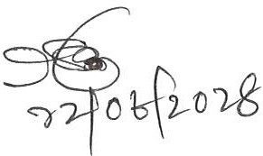
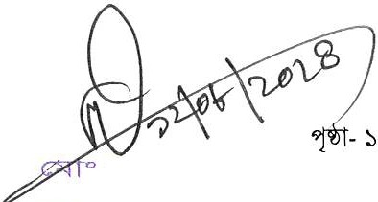

0 -!lf¼.*'""1 ->'1¢11::q
?fml.-'f<!> (151.')
1!1 . F<lf<rl!l"l
911.<1<1>WTT . 1,f<l>T I

p |  | 1%1%p- ooa-ol!> = :ioo |  |  | 1%1%p- o :i- = :ioo
 |  | o | o | o | 0 I? | O..I? | 0 8 | o 8
 |  |  | "' | 8 | a |  | 9 | IT
Jff <j | p | O.\'.l8 | ":i .'-' | ":i'-'.I!," | :i:i .aa | :i:i . a | :i '-'.a | :i l!>.\'.llr
Jff <j | Re-Reference Index | :;,a. 9 | :io .8\r | :io _:;,:i | - | - | - | -
Jff <j | 1.'71 (9faFl;..f-9fWl;J | <?.<?'-' | lr.ol;, | \r,O | -Ir | -'/(/ | -Ir | .Ir
Jff <j | '1/_'llfl | o.Slr | :i. '\ | o.8 | - (/ | o. l!, | -0 | - (/
 | p | \'.)O\r.:io | """ •lr" | ""a .:i:;, | :i:i .89 | :i:i .\rO | :i s.:il!> | :i lr.l!,I!,
 | Re-Reference Index | :;,s.s:i | :io .\'.JO | :io .9:i | - | - | - | -
 | 1.'71 (9/$-f 9fWl;J | <?,(?I!, | lr,l;,'-' | Ir,'\:;, | - (/ | -Ir | o. | 8.ol!,
 | 1.'71 | o.<?'-' | :i.<?lr | o.s:i | - '1 | o. | .lrl!, | -l!,
 | p | l!, ,O\r | 9\r.O\r | 9_:;, , | :i:i .I!, | :i:i'-'.o:;, | :i \'.l.oa | :i s. :i
 | Re-Reference Index | :;,l!,,:;,:i | :io .lr\'.l | :io\'.l. :;, | - | - | - | -
 | ,y_"f] (91$-!- | <?.8'\ | \h.<?:i | l!>.<?lr | -(/ | .Bir | - l!, | .lr8
 | '1/_'llfl | O,'-'l;, | 0,1!,l;, | 0,8<? | 0.80 | o.8 | o. l!I | o. 8

o" 1 '1_0'1.8 '!WT <! 9f<TTTI! ml:im<t (General) 91CTT'U- -91CTT'U 1<11'"4ilR> .Ir

i5l'>\ 11T 'Sf{ '1_0'1.8 .Ir i5l'>l |  |  | <! | 'I_0 I!> | :,a i5l'>ll |  | o'l.8 |  | WIS
<t i\!l 1<1J'"4i1Rl  - \!, i5l'>l <! 0'1.1!> | <l | <l | 8.o\!, IS .lr8 i5l'>\ 11'f 'Sf{  .lr IS .8b- i5l'>ll |  |  | o 8 | <l | 0.I!> IS

p cm"t |  | 1%1%p- ooa-ol!> = :ioo |  |  | 1%1%p- o :i- = :ioo
 |  | o | o | o | O I? | O..I? | 0 8 | o 8
 |  |  | "' | 8 | a |  | 9 | IT
Jff <j | p | :;,lr.89 | \'.l:il!>.8\'.l | \'.l:i9,:;.o | :i:i .:ia | :i:i .l!>a | :i .1r:;, | :i a."a
Jff <j | Re-Reference Index | :;,l!,_l!>a | :io .89 | :io _:;,s | . | . | . | .
Jff <j | 1.'71 (9!$-f 9fWl;J | <?.ol!, | l!,.I!, | \h.<?:i | .8(/ | -8 | .(fir | - '/
Jff <j | '1/. | 0.<?'\ | :i.% | o.8'\ | - Ir | o.8(1 | - (/ | .oo
 | p | '-''-'a.\'.JS | "al!>.9o | "a1r. 1r | :i:i:i.91!> | :i:i .I!, | :i '-'.a" | :i lr.1!>8
 | Re-Reference Index | :;,1!,_:ia | :io . lr | :io .9\'.l | . | . | - | -
 | 1.'71 (9/$-f 9fWl;J | 8.o:i | '\.:i:i | l!,,b-8 | - l!, | -l!, | 0.(/8 | 8.
 | 'J.'71 | 0,1!,l;, | .'\<? | 0,88 | .lrlr | o.'l'I | .(/Jr | 8.
<. |  | l!,1!,.8O | 1r:i.\'.l:;, | lr .9\r | :i:i .8O | :i:i .1!,9 | :i .ao | :i \'.l.\'.JO
<. | Re-Reference Index | 9. o | :io .M | :io\'.l.:ilr | - | - | . | -
<. | 1.'71 (9!$-f 9fWl;J | \h. 8 | \1,,0\r | I!,,!)(? | .8'1 | - o | lr. lr | -8
<. | 1.'71 ('111fw | o.8'-' | O,'\O | o.Slil | o. | o. 8 | o. 'I | o.l!,l!,

08 1 .:.,o.:.,8 '!WT 9f<ITrn ml:lm<t (General) 91CTT'U- -91CTT'U >f.<1l'"4ilR> ..:._q i5l'>l
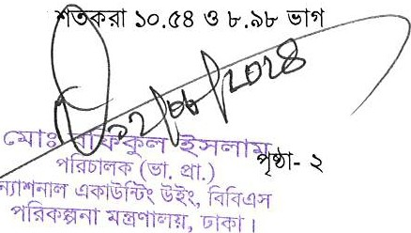
11T 'Sf{ o.:.,8 .ab- i5l'>l <! o " .81!>i5l'>ll o.:.,8 IS

<t 'i\!5 | 1<11'"4i11% |  | <r | 8 ..:., IS .81!> i5l'>l 11T1SJ:f o.:.,8
<! | o I!) | <l |  | .l!:>1!> IS ..:._o i5l'>\i

1,oa'

JJ Hl<!ilc'l |  |  | :,i!:i<!ilc'l |  |  | l«ll
'3!1'/f"5 -<o-<"- | -<o-<8 | -<0.'l" | Gll'if"5 -<o-<-<- | -<o-<" | o .b-(l' | . o
-<0-<-<- | -<0-<" | o .b-(l' | Gll'if"5 -<o-< - | -<o-<-< | 00,\!:,0 | .-<o

o(l'I | <il<li  . o 151'/fl | (Gll'if"5 -<o "-  <il | o-<8 ffl)  (Gll'if"5 -<o-< - | (Moving Average) 1<'1J fi!l  -<o-<" ffl) l<'ll | .-<o 151'/fl
o\!:,1 m-m  -s | l!:>81'G <l'81'G -<llmil t;i- \!) -t900 \!il•Ml .:i <il m  c$l" <1im I '5 -IS900 <!>Bl -<o-<8 Plf ff I |  |  |  |  | '["Ir
-<0-<8 | 9tffl 9iCTf{,- - l<'ll fi!l f.qf' .I!:>\!:,151'/fl

<Tt c'\Wf"t ffl (AR'<il ) <il GTT-s <il ffi ti
l!:>8 fG t;i- '1i:l t<!ii:l m 21m I!:>" i:tiK t900 <!>Bl
<il<I <il 'TT!rf ff I C l'-!llC<t<f> o 8 -m-c:,i ti l!:>8 fG 0Si"'1l
t900 <!>Bl AA -<o --<-<= oo (Group/Classification ff I f.lTir AA o - -<= oo <il<I <il f.rrn <!'Rt

IS 9f"-lff"W'!T:

<i> !Jli11C1t:-111 |  | 0 0- = 00 |  |  |  |  | o - = oo
 |  | · | lf(' | · | "" |  | lf!' s
 |  |  | " | 8 | a | \!:, | 9 | 'tr
:,ifl:ftiq'j |  | 'tr8.9\r | l!:>.l!:>9 | \!:,. 0 | - | 0.\:l\r | 'tr.'tr9 | - "
:,ifl:ftiq'j | Re-Reference Index | l!:>.1:>8 | o .as | o .l!:>I!:> | o. | - | - | -
:,ifl:ftiq'j | "trff:il1mr"/WtJ-f-9fUFl;J | d.'i | lb.8'i | lb,(/lb | 'i.i., | 'i.(/ | 'i. (/ | 'i. ,.,
:,ifl:ftiq'j | "trff:il1* | 0,0,:) | o. o | o. | o. 'i | o. 8 | o. ,., | o.
 |  | \ra,0\:l | \!:,.\r0 | l!:>. 9 | .ao | 0.1:> | - | .Sa
 | Re-Reference Index | l!:>. 9 | o .I:> | o .8\r | 0,01:) | - | - | -
 | "trff:il*1 ("/WtJ-f-9fUFl;J | (/.Ir | lb.,:)(/ | lb.8(1 | 'i.8'i | 'i.'i | Ir.,.,,., | Ir.
 | "trff:ilTm | -o.o | 0.08 | o.o | o.o | 0,,:) | o. ,., | o. o
 |  | \r .8 | "- a | ".89 | 0l!:>,l!:>9 | o. | 'tr. 8 | \r.80
 | Re-Reference Index | l!:>.<18 | o .9 | o . I!:> | o . \r | - | - | -
 | "trff:il1mr"/WtJ-f-9fUFl;J | (!.,:) | lb,(1(1 | lb.lbB | 'i.oo | lb. lb | 'i.8 | 'i.d
 | "trff:ilTm | O,O'i | o. lr | o. lb | o. lb | o. ,., | 0,,.,,., | o.
 |  | o.8 | 01:>. I:> | o--,_a\r | .00 | -"" | o. a | :, o.<1..:,
 | Re-Reference Index | \!:,. | 0 _99 | o . a | o.98 | - | - | -
 | "trff:il*1 (9fWIJ-§-9fUFl;J | d. lb | lb.lr'i | lb. | 'i.'ilb | Ir. | Ir.do | lr. 'i
 | "trff:ilTm | o. 8 | o. d | o. 'i | 0,,:)8 | 0,(1,:) | 0,,:)(1 | o.i.,
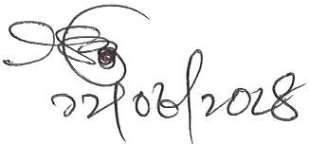
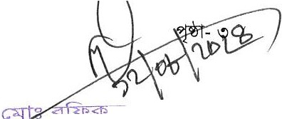
.
(;-.>-J<a-tl :i.l
?fPlo (''5t. ert.)
-rf1"Fllq ,!Fcil W'Z l.'l , ffi<!i"f
'1<f'fcf X•ll t<='Rf, lJf<lit I

o I  iSl'>lI | o 8 <£1  o 8 <£1 | 9lffl |  |  | (JjJ' )  ( , fxM, ) |  | 9,:,,-., iSl'>l (9fUfl,-t9frWG) <IT  9fUfl,- - |  | o 8 <£1  <T | 9.;,,a­  lr. .
9.<l' '3 lr. 9 -sf'>( <IT o 8 <£1 lr.'-''-', 9.8 '3 lr.<!'oiSl'>ll
o-., I | \!:l8ffl  Xff C$f | I | R | ff | 'i5 -IS91RJ | o 8  <P@ | -IS91RJ  o 8 | 9fr<I' '5l•Wll'$..:i <!!:'! |  | '3  I
. o 8 <£1 Jjf 9lffl 9fUfl,-t 9,:,,-., iSl'>l

f.tw' I

: 'Rt c ll!>IC.q<f> o 8 Ci5lm (Consumer Price Index-CPI) <!! o 8 (Wage Rate Index-WR!) o (<!!<!') ffll

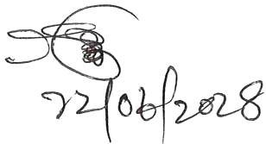
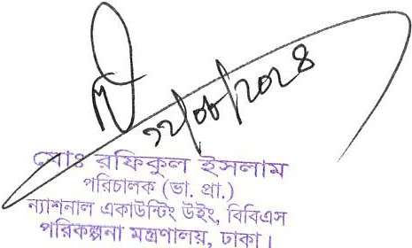

Month: July 2024

Consumer Price Index (CPI), Inflation Rate and Wage Rate Index (WRI) in Bangladesh

Published by:

Price & Wage Statistics Section National Accounting Wing Bangladesh Bureau of Statistics (BBS) E-27/A, Agargoan, Dhaka-1207

Please visit www.bbs.gov.bd ISBN: 978-984-475-095-1

This publication or any portion thereof cannot be copied, microfilmed or reproduced for any commercial purpose. Data therein can, however, be used and published with acknowledgement of their sources.

Bangladesh Bureau of Statistics (BBS), visit www.bbs.gov.bd


Director General
Bangladesh Bureau of Statistics (BBS) Statistics and Informatics Division (SID) Ministry of Planning

Preface
Bangladesh Bureau of Statistics (BBS) as the National Statistical Organization (NSO) has been engaged in collecting, collating and disseminating statistics on a wide range of economic, social, demographic and environmental variables. Monthly Release on Consumer Price Index (CPI), Inflation Rate and Wage Rate Index (WRI) is a regular publication. The present report is the 355th series of this publication.

Two independent sets of commodities (goods & services) are used to compute CPIs for rural and urban areas. The rural & urban both baskets cover 383 items with 749 varieties of goods & services. This index has been rebased with 2021-22 as reference index. The national CPI is calculated by combining the urban and rural indices using weight factors based on the Classification of Individual Consumption by Purpose (COICOP). The CPI items for the national and sub-national indices are classified into 12 major categories such as (i) Food and Nonalcoholic Beverages (ii) Alcoholic Beverages, Tobacco and Narcotics (iii) Clothing and Footwear (iv) Housing, Water, Electricity, Gas, and Other Fuels (v) Furnishings, Household Equipment, and Routine Maintenance of the House (vi) Health (vii) Transportation (viii) Communication (ix) Recreation and Culture (x) Education (xi) Restaurants and Hotels and (xii) Miscellaneous Goods and Services

WRI is intended to measure the movement of nominal wages of low paid skilled and unskilled labour over time in different sectors of the economy. This index has been rebased with 2021-22 as base/reference index. Monthly wages for specific 63 occupations (17 from the agriculture, 30 from the industry and the rest 16 from service sector) are considered for calculation of WRI.

I believe that the Monthly Release of Consumer Price Index (CPI), Inflation Rate and Wage Rate Index (WRI) in Bangladesh would be a useful document for the planners, policy makers, academicians, researchers, development partners/agencies and other stakeholders.

My appreciation is due to the officials of BBS at the Head Office and also to the field-level Statistical Offices for their relentless effort to make the work a success.

Any comments or suggestions would be highly appreciated.

Mohammed Mizanur Rahman

Contents
Chapter Particulars Page No.
- Consumer Price Index (CPI), Inflation Rate
Introduction 11
Consumer Price Index (CPI) 11
Classification 11
Aggregation 11
Index Basket and Weights 11
Price Collection Procedure 12
Consumer Price Index (CPI) and Inflation Rate (Point to Point) 13
12 Months moving average 14
Consumer Price Index (CPI): National (Over Previous Year/Month) 15
Consumer Price Index (CPI): Rural (Over Previous Year/Month) 17
Consumer Price Index (CPI): Urban (Over Previous Year/Month) 19
Historical Data (Time Series) of CPI National (Base: 1973-74 to 2005-06=100) 21
- Wage Rate Index (WRI) and Growth Rate of Bangladesh
Background of Wage Rate Index 25
Definition of Wage 25
Base year change 25
Computation of Wage Rate Index (WRI) 25
Derivation of weight 26
Coverage and sources of data 26
Wage Rate Index By Sectors: Bangladesh 27
Wage Rate Index By Sectors: Dhaka Division 28
Wage Rate Index By Sectors: Chittagong Division 29
Wage Rate Index By Sectors: Rajshahi Division 30
Wage Rate Index By Sectors: Rangpur Division 31
Wage Rate Index By Sectors: Khulna Division 32
Wage Rate Index By Sectors: Barisal Division 33
Wage Rate Index By Sectors: Sylhet Division 34
Wage Rate Index By Sectors: Mymensingh Division 35
Historical Data (Time Series) of WRI Bangladesh 36

- Annexure
Team of Price and Wage Statistics 41
References 42

Acronyms

BBS | Bangladesh Bureau of Statistics
BMPI | Building Materials Price Index
BSCO | Bangladesh Standard Classification of Occupation
BSIC | Bangladesh Standard Industrial Classification
CPI | Consumer Price Index
COICOP | Classification of Individual Consumption According to Purpose
GDP | Gross Domestic Product
GNP | Gross National Product
GNI | Gross National Income
HIES | Household Income and Expenditure Survey
HRI | House Rent Index
ISCO | International Standard Classification of Occupation
LFS | Labour Force Survey
NSO | National Statistical Organization
SID | Statistics and Informatics Division
WPI | Wholesale Price Index
WRI | Wage Rate Index

Chapter 1

Consumer Price Index (CPI) and Inflation Rate

Introduction:
The Bangladesh Bureau of Statistics (BBS) as the national statistical organization (NSO) has been engaged in collecting, collating and disseminating statistics on a wide range of economic, social, demographic and environmental variables. It brings out various regular and ad hoc publications and reports for dissemination of generated data. There has been persistent attempt to satisfy the data needs of the country by undertaking initiatives to generate timely, relevant and quality statistics. This Monthly CPI Release is an addition to its on-going efforts to satisfy the need of relevant data by the Government and other stakeholders. The Release is designed to provide a regular update on monthly price and wage situation in the country. It focuses on (i) consumer price index and (ii) inflation.

Consumer Price Index (CPI):
The consumer price index (CPI) reflects the average change over time in the prices of a specified set of final commodities and services representing the market basket of a given group of consumers.

Classification:
Food and Non-food CPIs for national, urban and rural groups are classified by (i) Food and Nonalcoholic Beverages (ii) Alcoholic Beverages, Tobacco and Narcotics (iii) Clothing and Footwear (iv) Housing, Water, Electricity, Gas, and Other Fuels (v) Furnishings, Household Equipment, and Routine Maintenance of the House (vi) Health (vii) Transportation (viii) Communication (ix) Recreation and Culture (x) Education (xi) Restaurants and Hotels and (xii) Miscellaneous Goods and Services.

Aggregation:
The indices are shown by general aggregation and separately by food and non-food groups. The Release includes CPI for three groups of population: (1) national, (2) urban and (3) rural. National, urban and rural CPIs have been constructed with 2021-22 as the base year. The base year weights have been derived from the Household Income and Expenditure Survey (HIES), 2016-17.

Index Basket and Weights:
For computation of CPIs, two consumer baskets are used: (i) urban basket and (ii) rural basket. These baskets items (goods and services) were determined based on HIES, 2016-17 for private consumption of population. The rural & urban both baskets covers 383 items with 749 varieties of food and non-food items (goods and services). The items weights in the base year were derived on the basis of the average expenditure incurred by a household on the item expressed in terms of its percentage share in the total expenditure on all items. The index basket is divided into twelve major groups of items.

CPIs are calculated at two stages:
First, Elementary Indexes are compiled using Jevons formula & chained Jevons.
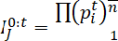

Where, 0 and t are two periods

Second, Higher-level indexes are compiled using the Modified Young’s formula.
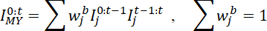

Where,
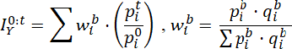

Inflation Rate:

I2 – I1
IR= x100
I1

Where,
IR = Inflation Rate
I2 = Index in the current year/month I1 = Index in the previous year/month

Price Collection Procedure:
BBS collects price data from 154 [90 from urban (12 from Dhaka City, 04 from Chattogram City, 18 from Other 06 Divisional City, 56 from other 56 Districts) and 64 from rural in 64 Districts] main markets across the country. Three price quotes per items with varieties are collected from each of the market. Both of rural and urban, Prices of 127 food items with 242 varieties as well as 256 non-food items with 507 varieties are collected. In collecting prices, rural and urban is monthly and Dhaka & Chattogram City Corporation is weekly each month. Data are usually collected from selected shops in each market or selected units or service providers in case of services. In constructing price indices, the average price for each item is considered.

Table: 1.1 Consumer Price Index (CPI) and Inflation Rate (Point to Point)

CPI Classification | 2021-22 | 2022-23 | 2023-24 | (Base Index 2021-22 =100)
 |  |  |  | 2022-23 |  | 2023-24 |  |  | 2024-25
 |  |  |  | May’23 | Jun’23 | Jul’23 | May’24 | Jun’24 | Jul’24
1 | 2 | 3 | 4 | 5 | 6 | 7 | 8 | 9 | 10
NATIONAL
General index | 306.18 | 109.02 | 119.63 | 111.06 | 112.46 | 112.89 | 122.04 | 123.38 | 126.06
Inflation | 6.15 | 9.02 | 9.73 | 9.94 | 9.74 | 9.69 | 9.89 | 9.72 | 11.66
Food index | 332.86 | 108.71 | 120.30 | 109.62 | 112.25 | 112.74 | 121.42 | 123.94 | 128.64
Inflation | 6.05 | 8.71 | 10.65 | 9.24 | 9.73 | 9.76 | 10.76 | 10.42 | 14.10
Non-food index | 271.98 | 109.39 | 119.08 | 112.22 | 112.63 | 113.02 | 122.54 | 122.93 | 123.96
Inflation | 6.31 | 9.39 | 8.86 | 9.96 | 9.60 | 9.47 | 9.19 | 9.15 | 9.68
RURAL
General index | 304.76 | 109.08 | 119.73 | 111.15 | 112.55 | 112.95 | 122.26 | 123.59 | 126.38
Inflation | 6.42 | 9.08 | 9.76 | 9.84 | 9.82 | 9.75 | 9.99 | 9.81 | 11.89
Food index | 326.34 | 108.79 | 120.41 | 110.08 | 112.47 | 112.80 | 121.90 | 124.16 | 128.66
Inflation | 6.51 | 8.79 | 10.67 | 9.32 | 9.95 | 9.82 | 10.73 | 10.39 | 14.06
Non-food index | 270.42 | 109.54 | 119.10 | 112.16 | 112.62 | 113.09 | 122.61 | 123.05 | 124.21
Inflation | 6.25 | 9.54 | 8.71 | 9.83 | 9.52 | 9.48 | 9.31 | 9.26 | 9.84
URBAN
General index | 308.81 | 108.87 | 119.30 | 110.74 | 112.15 | 112.65 | 121.50 | 122.89 | 125.35
Inflation | 5.66 | 8.87 | 9.57 | 9.98 | 9.45 | 9.43 | 9.72 | 9.58 | 11.27
Food index | 348.75 | 108.52 | 120.09 | 108.63 | 111.76 | 112.62 | 120.43 | 123.53 | 128.64
Inflation | 5.02 | 8.52 | 10.65 | 9.13 | 9.26 | 9.63 | 10.86 | 10.54 | 14.22
Non-food index | 274.07 | 109.13 | 118.81 | 112.05 | 112.40 | 112.67 | 122.17 | 122.50 | 123.30
Inflation | 6.38 | 9.13 | 8.87 | 9.90 | 9.47 | 9.20 | 9.03 | 8.98 | 9.43
Note : Figures in italics indicate inflation over previous year/month
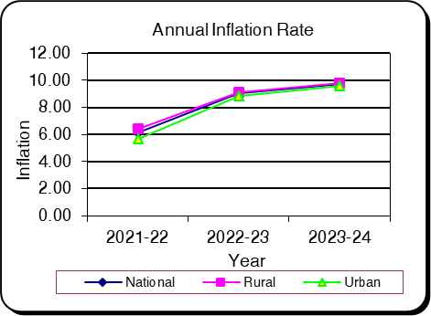
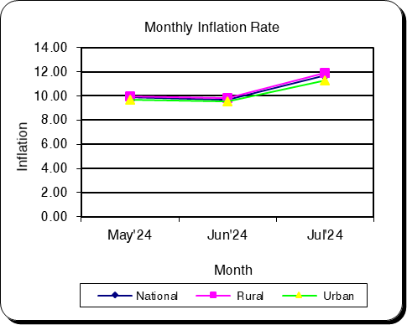

Table: 1.2 Monthly and average inflation rate of CPI from Aug’23 to Jul’24 (12 Months moving average)
(Base Index: 2021-22=100)
12 Months Average |  | 12 Months Average |  | Inflation
Period | Average | Period | Average | Inflation
1 | 2 | 3 | 4 | 5
Aug'22-Jul'23 | 109.85 | Aug'21-Jul'22 | 100.60 | 9.20
Sep'22-Aug'23 | 110.73 | Sep'21-Aug'22 | 101.37 | 9.24
Oct'22-Sep'23 | 111.60 | Oct'21-Sep'22 | 102.12 | 9.29
Nov'22-Oct'23 | 112.51 | Nov'21-Oct'22 | 102.87 | 9.37
Dec'22-Nov'23 | 113.37 | Dec'21-Nov'22 | 103.60 | 9.42
Jan'23-Dec'23 | 114.22 | Jan'22-Dec'22 | 104.33 | 9.48
Feb'23-Jan'24 | 115.11 | Feb'22-Jan'23 | 105.04 | 9.59
Mar'23-Feb'24 | 115.99 | Mar'22-Feb'23 | 105.78 | 9.66
Apr'23-Mar'24 | 116.90 | Apr'22-Mar'23 | 106.57 | 9.69
May'23-Apr'24 | 117.80 | May'22-Apr'23 | 107.35 | 9.73
Jun'23-May'24 | 118.72 | Jun'22-May'23 | 108.19 | 9.73
Jul'23-Jun'24 | 119.63 | Jul'22-Jun'23 | 109.02 | 9.73
Aug'23-Jul'24 | 120.73 | Aug'22-Jul'23 | 109.85 | 9.90
Aug'23-Jul'24 |  |  | 9.90
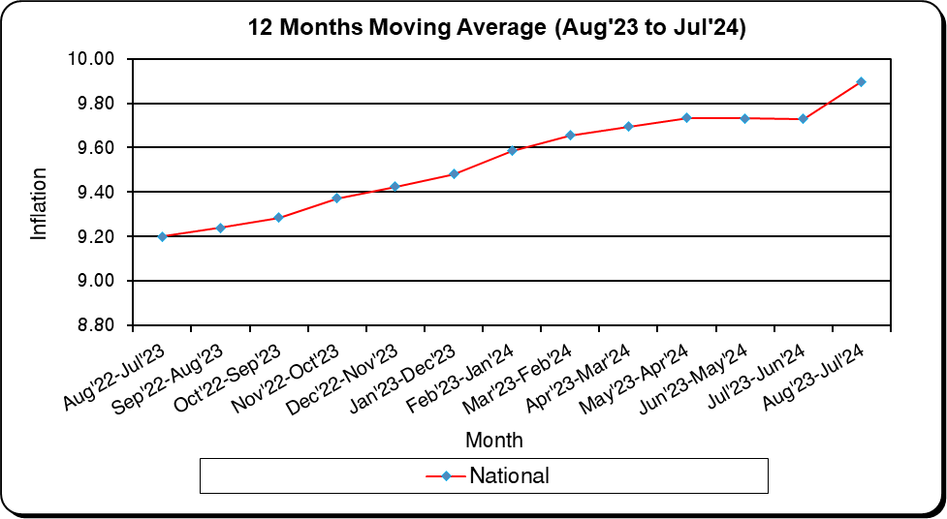

Table: 1.3 Consumer Price Index (CPI): National (Over Previous Year/Month)

CPI Classification | 2021-22 | 2022-23 | 2023-24 | (Base Index 2021-22 =100)
 |  |  |  | 2022-23 |  | 2023-24 |  |  | 2024-25
 |  |  |  | May’23 | Jun’23 | Jul’23 | May’24 | Jun’24 | Jul’24
1 | 2 | 3 | 4 | 5 | 6 | 7 | 8 | 9 | 10
General Index | 306.18 | 109.02 | 119.63 | 111.06 | 112.46 | 112.89 | 122.04 | 123.38 | 126.06
Inflation (Point to  Point) | 6.15 | 9.02 | 9.73 | 9.94 | 9.74 | 9.69 | 9.89 | 9.72 | 11.66
Inflation (Over  Previous Month) | * | * | * | -0.35 | 1.26 | 0.39 | -0.21 | 1.11 | 2.17
Food | 332.86 | 108.71 | 120.30 | 109.62 | 112.25 | 112.74 | 121.42 | 123.94 | 128.64
Inflation (Point to  Point) | 6.05 | 8.71 | 10.65 | 9.24 | 9.73 | 9.76 | 10.76 | 10.42 | 14.10
Inflation (Over Previous Month) | * | * | * | -1.47 | 2.39 | 0.44 | -0.99 | 2.08 | 3.79
Non-Food | 271.98 | 109.39 | 119.08 | 112.22 | 112.63 | 113.02 | 122.54 | 122.93 | 123.96
Inflation (Point to  Point) | 6.31 | 9.39 | 8.86 | 9.96 | 9.60 | 9.47 | 9.19 | 9.15 | 9.68
Inflation (Over  Previous Month) | * | * | * | 0.56 | 0.37 | 0.34 | 0.42 | 0.32 | 0.84
Division Wise (COICOP)
01. Food and Nonalcoholic Beverages | 332.86 | 108.71 | 120.30 | 109.62 | 112.25 | 112.74 | 121.42 | 123.94 | 128.64
Inflation (Point to  Point) | 6.05 | 8.71 | 10.65 | 9.24 | 9.73 | 9.76 | 10.76 | 10.42 | 14.10
Inflation (Over  Previous Month) | * | * | * | -1.47 | 2.39 | 0.44 | -0.99 | 2.08 | 3.79
02. Alcoholic Beverages, Tobacco  and Narcotics | * | * | 121.23 | 117.11 | 117.77 | 117.90 | 124.59 | 129.44 | 135.38
Inflation (Point to  Point) | * | * | * | * | * | * | 6.38 | 9.91 | 14.83
Inflation (Over  Previous Month) | * | * | * | 1.13 | 0.56 | 0.11 | 0.34 | 3.90 | 4.59
03. Clothing and Footwear | 320.14 | 106.71 | 115.73 | 108.18 | 108.40 | 108.88 | 118.34 | 118.43 | 118.80
Inflation (Point to  Point) | 7.38 | 6.71 | 8.44 | 5.14 | 4.82 | 4.69 | 9.40 | 9.24 | 9.11
Inflation (Over Previous Month) | * | * | * | 0.18 | 0.21 | 0.44 | 0.03 | 0.07 | 0.32
04. Housing, Water, Electricity, Gas, and Other Fuels | 232.43 | 108.25 | 118.94 | 112.40 | 113.39 | 113.84 | 123.12 | 123.23 | 123.93
Inflation (Point to  Point) | 1.81 | 8.25 | 9.89 | 11.17 | 11.92 | 12.17 | 9.53 | 8.68 | 8.86
Inflation (Over Previous Month) | * | * | * | 0.62 | 0.88 | 0.40 | 0.28 | 0.09 | 0.57
05. Furnishings, Household Equipment,  and Routine MaintenanceoftheHouse | 320.30 | 109.68 | 123.81 | 113.93 | 114.03 | 114.22 | 126.85 | 126.96 | 127.09
Inflation (Point to  Point) | 7.43 | 9.68 | 12.89 | 11.12 | 10.34 | 10.33 | 11.34 | 11.33 | 11.26
Inflation (Over Previous Month) | * | * | * | 0.12 | 0.09 | 0.17 | 0.12 | 0.08 | 0.10

CPI Classification | 2021-22 | 2022-23 | 2023-24 | (Base Index 2021-22 =100)
 |  |  |  | 2022-23 |  | 2023-24 |  |  | 2024-25
 |  |  |  | May’23 | Jun’23 | Jul’23 | May’24 | Jun’24 | Jul’24
1 | 2 | 3 | 4 | 5 | 6 | 7 | 8 | 9 | 10
06. Health | 253.62 | 114.09 | 118.23 | 109.50 | 109.52 | 109.92 | 123.06 | 123.77 | 124.50
Inflation (Point to  Point) | 2.32 | 14.09 | 3.85 | 8.89 | 8.67 | 8.80 | 12.38 | 13.01 | 13.27
Inflation (Over Previous Month) | * | * | * | 1.35 | 0.02 | 0.36 | 0.18 | 0.57 | 0.59
07. Transportation | 313.00 | 109.67 | 117.62 | 110.38 | 110.52 | 110.64 | 119.33 | 119.48 | 119.79
Inflation (Point to  Point) | 15.31 | 9.67 | 7.25 | 7.71 | 6.54 | 6.41 | 8.11 | 8.10 | 8.27
Inflation (Over  Previous Month) | * | * | * | 0.24 | 0.13 | 0.10 | 0.14 | 0.12 | 0.26
08. Communication | * | * | 107.62 | 106.64 | 106.64 | 106.65 | 110.31 | 110.36 | 114.08
Inflation (Point to  Point) | * | * | * | * | * | * | 3.45 | 3.49 | 6.97
Inflation (Over Previous Month) | * | * | * | 0.00 | 0.00 | 0.01 | 1.82 | 0.04 | 3.37
09. Recreation  and Culture | 202.60 | 108.58 | 123.75 | 114.65 | 114.94 | 115.53 | 127.37 | 127.68 | 128.29
Inflation (Point to  Point) | 4.64 | 8.58 | 14.01 | 11.96 | 10.74 | 10.53 | 11.09 | 11.08 | 11.04
Inflation (Over  Previous Month) | * | * | * | 0.22 | 0.25 | 0.51 | 0.62 | 0.24 | 0.48
10. Education | * | * | 112.93 | 109.37 | 109.37 | 109.68 | 115.64 | 115.67 | 116.42
Inflation (Point to  Point) | * | * | * | * | * | * | 5.73 | 5.75 | 6.15
Inflation (Over Previous Month) | * | * | * | 0.11 | 0.00 | 0.28 | 1.21 | 0.02 | 0.65
11. Restaurants and Hotels | * | * | 140.32 | 136.56 | 137.45 | 138.91 | 144.70 | 144.76 | 146.68
Inflation (Point to  Point) | * | * | * | * | * | * | 5.95 | 5.32 | 5.59
Inflation (Over  Previous Month) | * | * | * | 2.81 | 0.65 | 1.07 | 1.44 | 0.04 | 1.33
12. Miscellaneous  Goods and Services | 312.28 | 112.05 | 122.53 | 111.87 | 111.96 | 112.60 | 128.25 | 128.54 | 129.83
Inflation (Point to  Point) | 8.23 | 12.05 | 9.33 | 8.78 | 7.42 | 6.06 | 14.64 | 14.81 | 15.30
Inflation (Over Previous Month) | * | * | * | 0.25 | 0.08 | 0.57 | 0.71 | 0.22 | 1.00
Note : Figures in italics indicate inflation over previous year/month
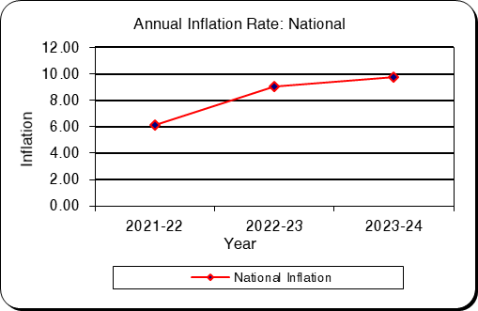
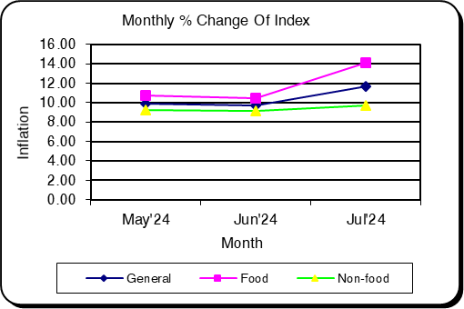

Table: 1.4 Consumer Price Index (CPI): Rural (Over Previous Year/Month)
CPI Classification | 2021-22 | 2022-23 | 2023-24 | (Base Index 2021-22 =100)
 |  |  |  | 2022-23 |  | 2023-24 |  |  | 2024-25
 |  |  |  | May’23 | Jun’23 | Jul’23 | May’24 | Jun’24 | Jul’24
1 | 2 | 3 | 4 | 5 | 6 | 7 | 8 | 9 | 10
General Index | 304.76 | 109.08 | 119.73 | 111.15 | 112.55 | 112.95 | 122.26 | 123.59 | 126.38
Inflation (Point to  Point) | 6.42 | 9.08 | 9.76 | 9.84 | 9.82 | 9.75 | 9.99 | 9.81 | 11.89
Inflation (Over  Previous Month) | * | * | * | -0.35 | 1.25 | 0.36 | -0.29 | 1.09 | 2.25
Food | 326.34 | 108.79 | 120.41 | 110.08 | 112.47 | 112.80 | 121.90 | 124.16 | 128.66
Inflation (Point to  Point) | 6.51 | 8.79 | 10.67 | 9.32 | 9.95 | 9.82 | 10.73 | 10.39 | 14.06
Inflation (Over  Previous Month) | * | * | * | -1.43 | 2.17 | 0.29 | -1.01 | 1.86 | 3.63
Non-Food | 270.42 | 109.54 | 119.10 | 112.16 | 112.62 | 113.09 | 122.61 | 123.05 | 124.21
Inflation (Point to  Point) | 6.25 | 9.54 | 8.71 | 9.83 | 9.52 | 9.48 | 9.31 | 9.26 | 9.84
Inflation (Over  Previous Month) | * | * | * | 0.67 | 0.40 | 0.42 | 0.40 | 0.36 | 0.94
Division Wise (COICOP)
01. Food and Nonalcoholic  Beverages | 326.34 | 108.79 | 120.41 | 110.08 | 112.47 | 112.80 | 121.90 | 124.16 | 128.66
Inflation (Point to  Point) | 6.51 | 8.79 | 10.67 | 9.32 | 9.95 | 9.82 | 10.73 | 10.39 | 14.06
Inflation (Over  Previous Month) | * | * | * | -1.43 | 2.17 | 0.29 | -1.01 | 1.86 | 3.63
02. Alcoholic Beverages, Tobacco  and Narcotics | * | * | 120.24 | 118.02 | 118.81 | 118.95 | 123.81 | 128.62 | 136.95
Inflation (Point to  Point) | * | * | * | * | * | * | 4.91 | 8.26 | 15.12
Inflation (Over  Previous Month) | * | * | * | 1.25 | 0.67 | 0.13 | 0.47 | 3.89 | 6.47
03. Clothing and Footwear | 318.29 | 106.63 | 113.95 | 106.77 | 107.00 | 107.44 | 116.45 | 116.49 | 116.81
Inflation (Point to  Point) | 6.50 | 6.63 | 6.86 | 3.58 | 3.22 | 3.11 | 9.06 | 8.87 | 8.73
Inflation (Over  Previous Month) | * | * | * | 0.15 | 0.22 | 0.41 | 0.03 | 0.03 | 0.28
04. Housing, Water, Electricity, Gas, and Other Fuels | 223.88 | 109.32 | 121.36 | 113.38 | 114.54 | 115.25 | 125.43 | 125.57 | 126.53
Inflation (Point to  Point) | 1.66 | 9.32 | 11.02 | 12.00 | 13.03 | 13.60 | 10.63 | 9.63 | 9.79
Inflation (Over Previous Month) | * | * | * | 0.72 | 1.02 | 0.61 | 0.06 | 0.11 | 0.76
05. Furnishings, Household Equipment,  and Routine MaintenanceoftheHouse | 308.52 | 108.99 | 124.08 | 114.70 | 114.81 | 115.02 | 126.63 | 126.71 | 126.73
Inflation (Point to  Point) | 7.63 | 8.99 | 13.91 | 12.24 | 11.00 | 10.89 | 10.40 | 10.37 | 10.18
Inflation (Over Previous Month) | * | * | * | 0.12 | 0.10 | 0.19 | 0.06 | 0.06 | 0.01

CPI Classification | 2021-22 | 2022-23 | 2023-24 | (Base Index 2021-22 =100)
 |  |  |  | 2022-23 |  | 2023-24 |  |  | 2024-25
 |  |  |  | May’23 | Jun’23 | Jul’23 | May’24 | Jun’24 | Jul’24
1 | 2 | 3 | 4 | 5 | 6 | 7 | 8 | 9 | 10
06. Health | 269.97 | 116.61 | 120.18 | 109.33 | 109.34 | 109.75 | 126.21 | 126.88 | 126.91
Inflation (Point to  Point) | 2.25 | 16.61 | 3.46 | 8.71 | 8.62 | 8.99 | 15.45 | 16.04 | 15.64
Inflation (Over  Previous Month) | * | * | * | 1.38 | 0.02 | 0.37 | 0.00 | 0.53 | 0.03
07. Transportation | 274.69 | 108.62 | 118.35 | 110.50 | 110.68 | 110.85 | 120.27 | 120.45 | 120.72
Inflation (Point to  Point) | 17.33 | 8.62 | 8.96 | 7.20 | 6.58 | 6.59 | 8.84 | 8.82 | 8.91
Inflation (Over Previous Month) | * | * | * | 0.07 | 0.16 | 0.15 | 0.05 | 0.15 | 0.23
08. Communication | * | * | 105.82 | 105.22 | 105.22 | 105.23 | 107.42 | 107.42 | 111.26
Inflation (Point to  Point) | * | * | * | * | * | * | 2.09 | 2.09 | 5.72
Inflation (Over Previous Month) | * | * | * | 0.00 | 0.00 | 0.01 | 0.69 | 0.00 | 3.57
09. Recreation and Culture | 225.50 | 108.10 | 122.07 | 114.25 | 114.63 | 115.40 | 125.50 | 125.95 | 126.49
Inflation (Point to  Point) | 5.12 | 8.10 | 12.97 | 11.60 | 10.43 | 10.37 | 9.84 | 9.88 | 9.61
Inflation (Over Previous Month) | * | * | * | 0.24 | 0.33 | 0.67 | 0.43 | 0.36 | 0.43
10. Education | * | * | 108.28 | 106.19 | 106.19 | 106.54 | 111.19 | 111.19 | 111.65
Inflation (Point to  Point) | * | * | * | * | * | * | 4.71 | 4.71 | 4.80
Inflation (Over Previous Month) | * | * | * | 0.15 | 0.00 | 0.33 | 2.05 | 0.00 | 0.41
11. Restaurants  and Hotels | * | * | 135.08 | 134.07 | 134.77 | 136.07 | 140.25 | 140.26 | 141.79
Inflation (Point to  Point) | * | * | * | * | * | * | 4.61 | 4.07 | 4.20
Inflation (Over  Previous Month) | * | * | * | 4.34 | 0.52 | 0.96 | 2.59 | 0.01 | 1.09
12. Miscellaneous Goods and Services | 332.14 | 111.24 | 120.42 | 111.87 | 111.96 | 112.63 | 125.32 | 125.60 | 126.53
Inflation (Point to  Point) | 8.61 | 11.24 | 8.24 | 9.24 | 7.60 | 6.22 | 12.02 | 12.18 | 12.34
Inflation (Over Previous Month) | * | * | * | 0.25 | 0.08 | 0.60 | 0.82 | 0.23 | 0.74
Note : Figures in italics indicate inflation over previous year/month
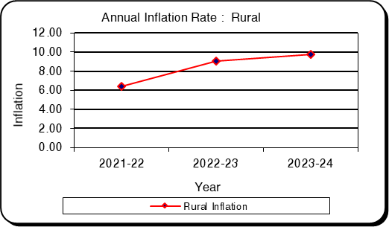
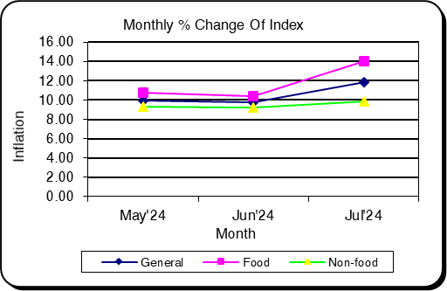

Table: 1.5 Consumer Price Index (CPI): Urban (Over Previous Year/Month)

CPI Classification | 2021-22 | 2022-23 | 2023-24 | (Base Index 2021-22 =100)
 |  |  |  | 2022-23 |  | 2023-24 |  |  | 2024-25
 |  |  |  | May’23 | Jun’23 | Jul’23 | May’24 | Jun’24 | Jul’24
1 | 2 | 3 | 4 | 5 | 6 | 7 | 8 | 9 | 10
General Index | 308.81 | 108.87 | 119.30 | 110.74 | 112.15 | 112.65 | 121.50 | 122.89 | 125.35
Inflation (Point to  Point) | 5.66 | 8.87 | 9.57 | 9.98 | 9.45 | 9.43 | 9.72 | 9.58 | 11.27
Inflation (Over  Previous Month) | * | * | * | -0.33 | 1.28 | 0.45 | -0.09 | 1.15 | 2.00
Food | 348.75 | 108.52 | 120.09 | 108.63 | 111.76 | 112.62 | 120.43 | 123.53 | 128.64
Inflation (Point to  Point) | 5.02 | 8.52 | 10.65 | 9.13 | 9.26 | 9.63 | 10.86 | 10.54 | 14.22
Inflation (Over Previous Month) | * | * | * | -1.56 | 2.88 | 0.77 | -0.95 | 2.58 | 4.13
Non-Food | 274.07 | 109.13 | 118.81 | 112.05 | 112.40 | 112.67 | 122.17 | 122.50 | 123.30
Inflation (Point to  Point) | 6.38 | 9.13 | 8.87 | 9.90 | 9.47 | 9.20 | 9.03 | 8.98 | 9.43
Inflation (Over Previous Month) | * | * | * | 0.43 | 0.31 | 0.24 | 0.44 | 0.27 | 0.66
Division Wise (COICOP)
01. Food and Nonalcoholic  Beverages | 348.75 | 108.52 | 120.09 | 108.63 | 111.76 | 112.62 | 120.43 | 123.53 | 128.64
Inflation (Point to  Point) | 5.02 | 8.52 | 10.65 | 9.13 | 9.26 | 9.63 | 10.86 | 10.54 | 14.22
Inflation (Over Previous Month) | * | * | * | -1.56 | 2.88 | 0.77 | -0.95 | 2.58 | 4.13
02. Alcoholic  Beverages, Tobacco and Narcotics | * | * | 123.67 | 114.89 | 115.23 | 115.31 | 126.50 | 131.45 | 131.56
Inflation (Point to  Point) | * | * | * | * | * | * | 10.11 | 14.08 | 14.10
Inflation (Over  Previous Month) | * | * | * | 0.83 | 0.30 | 0.07 | 0.03 | 3.92 | 0.09
03. Clothing and Footwear | 323.66 | 106.87 | 119.14 | 110.87 | 111.09 | 111.65 | 121.99 | 122.16 | 122.61
Inflation (Point to  Point) | 9.06 | 6.87 | 11.49 | 8.11 | 7.89 | 7.72 | 10.03 | 9.97 | 9.81
Inflation (Over Previous Month) | * | * | * | 0.23 | 0.20 | 0.51 | 0.04 | 0.14 | 0.37
04. Housing, Water, Electricity, Gas, and Other Fuels | 242.32 | 107.07 | 116.10 | 111.26 | 112.04 | 112.18 | 120.40 | 120.48 | 120.88
Inflation (Point to  Point) | 1.98 | 7.07 | 8.44 | 10.17 | 10.61 | 10.50 | 8.21 | 7.54 | 7.75
Inflation (Over Previous Month) | * | * | * | 0.50 | 0.70 | 0.13 | 0.54 | 0.07 | 0.33
05. Furnishings, Household Equipment, and Routine  MaintenanceoftheHouse | 341.00 | 110.75 | 123.31 | 112.52 | 112.61 | 112.77 | 127.25 | 127.40 | 127.73
Inflation (Point to  Point) | 7.11 | 10.75 | 11.32 | 9.17 | 9.11 | 9.24 | 13.09 | 13.13 | 13.27
Inflation (Over  Previous Month) | * | * | * | 0.12 | 0.08 | 0.14 | 0.23 | 0.12 | 0.26

CPI Classification | 2021-22 | 2022-23 | 2023-24 | (Base Index 2021-22 =100)
 |  |  |  | 2022-23 |  | 2023-24 |  |  | 2024-25
 |  |  |  | May’23 | Jun’23 | Jul’23 | May’24 | Jun’24 | Jul’24
1 | 2 | 3 | 4 | 5 | 6 | 7 | 8 | 9 | 10
06. Health | 225.63 | 108.92 | 114.40 | 109.85 | 109.87 | 110.26 | 116.86 | 117.65 | 119.76
Inflation (Point to  Point) | 2.48 | 8.92 | 5.05 | 9.24 | 8.74 | 8.40 | 6.38 | 7.08 | 8.62
Inflation (Over  Previous Month) | * | * | * | 1.28 | 0.02 | 0.36 | 0.56 | 0.68 | 1.79
07. Transportation | 355.22 | 110.56 | 117.40 | 110.24 | 110.36 | 110.43 | 119.03 | 119.15 | 119.45
Inflation (Point to  Point) | 13.64 | 10.56 | 6.21 | 8.12 | 6.47 | 6.23 | 7.97 | 7.97 | 8.17
Inflation (Over Previous Month) | * | * | * | 0.42 | 0.10 | 0.07 | 0.23 | 0.10 | 0.25
08. Communication | * | * | 110.46 | 108.86 | 108.86 | 108.87 | 114.86 | 114.99 | 118.51
Inflation (Point to  Point) | * | * | * | * | * | * | 5.52 | 5.63 | 8.86
Inflation (Over  Previous Month) | * | * | * | 0.00 | 0.00 | 0.01 | 3.53 | 0.11 | 3.07
09. Recreation and Culture | 177.90 | 109.33 | 125.95 | 115.61 | 115.74 | 116.01 | 130.17 | 130.36 | 130.84
Inflation (Point to  Point) | 4.00 | 9.33 | 15.23 | 12.85 | 11.51 | 11.00 | 12.60 | 12.63 | 12.79
Inflation (Over Previous Month) | * | * | * | 0.18 | 0.11 | 0.23 | 0.71 | 0.15 | 0.37
10. Education | * | * | 116.23 | 110.24 | 110.24 | 110.54 | 118.67 | 118.74 | 119.97
Inflation (Point to  Point) | * | * | * | * | * | * | 7.65 | 7.70 | 8.54
Inflation (Over Previous Month) | * | * | * | 0.13 | 0.00 | 0.27 | 0.00 | 0.06 | 1.04
11. Restaurants  and Hotels | * | * | 147.62 | 140.54 | 141.63 | 143.40 | 150.93 | 151.08 | 153.20
Inflation (Point to  Point) | * | * | * | * | * | * | 7.39 | 6.67 | 6.84
Inflation (Over  Previous Month) | * | * | * | 0.68 | 0.77 | 1.25 | 0.00 | 0.10 | 1.41
12. Miscellaneous Goods and Services | 287.76 | 113.16 | 124.68 | 111.67 | 111.77 | 112.35 | 131.04 | 131.33 | 133.07
Inflation (Point to  Point) | 7.70 | 13.16 | 10.18 | 7.94 | 6.98 | 5.64 | 17.34 | 17.50 | 18.44
Inflation (Over  Previous Month) | * | * | * | 0.24 | 0.08 | 0.52 | 0.54 | 0.22 | 1.33
Note : Figures in italics indicate inflation over previous year/month
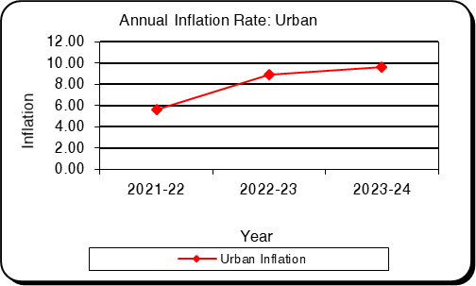
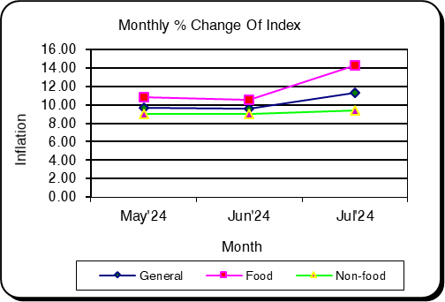

Table: 1.6 Historical Data (Time Series) of CPI National (Base: 1973-74 to 2005-06=100)
Year | Index |  |  | Inflation
Year | General | Food | Non-food | General | Food | Non-food
1 | 2 | 3 | 4 | 5 | 6 | 7
Base: 1973-74 = 100
1973-74 | 100.00 | 100.00 | 100.00
1974-75 | 167.17 | 176.89 | 150.79 | 67.17 | 76.89 | 50.79
1975-76 | 153.19 | 148.60 | 160.90 | -8.36 | -15.99 | 6.70
1976-77 | 156.89 | 150.16 | 167.97 | 2.42 | 1.05 | 4.39
1977-78 | 176.69 | 173.65 | 181.13 | 12.62 | 15.64 | 7.84
1978-79 | 191.24 | 185.45 | 200.97 | 8.23 | 6.80 | 10.95
1979-80 | 226.55 | 225.16 | 230.31 | 18.46 | 21.41 | 14.60
1980-81 | 254.97 | 244.69 | 272.47 | 12.54 | 8.67 | 18.31
1981-82 | 296.50 | 288.15 | 310.56 | 16.29 | 17.76 | 13.98
1982-83 | 325.94 | 312.77 | 348.11 | 9.93 | 8.54 | 12.09
1983-84 | 357.47 | 350.47 | 369.27 | 9.67 | 12.05 | 6.08
1984-85 | 396.58 | 387.89 | 411.21 | 10.94 | 10.68 | 11.36
1985-86 | 436.03 | 429.46 | 447.11 | 9.95 | 10.72 | 8.73
1986-87 | 481.18 | 483.42 | 477.41 | 10.35 | 12.56 | 6.78
Base: 1985-86 = 100
1985-86 | 100.00 | 100.00 | 100.00
1986-87 | 113.87 | 115.44 | 111.03 | 13.87 | 15.44 | 11.03
1987-88 | 121.12 | 123.38 | 117.03 | 6.37 | 6.88 | 5.40
1988-89 | 131.30 | 133.66 | 127.02 | 8.40 | 8.33 | 8.54
1989-90 | 136.37 | 137.04 | 135.15 | 3.86 | 2.53 | 6.40
1990-91 | 147.70 | 148.11 | 146.95 | 8.31 | 8.08 | 8.73
1991-92 | 154.44 | 154.30 | 154.69 | 4.56 | 4.18 | 5.27
1992-93 | 158.67 | 157.17 | 161.38 | 2.74 | 1.86 | 4.32
1993-94 | 163.87 | 161.80 | 167.69 | 3.28 | 2.95 | 3.91
1994-95 | 178.40 | 176.77 | 181.38 | 8.87 | 9.25 | 8.16
1995-96 | 190.27 | 189.13 | 191.86 | 6.65 | 6.99 | 5.78
1996-97 | 195.07 | 191.85 | 200.99 | 2.52 | 1.44 | 4.76
Base: 1995-96 = 100
1995-96 | 100.00 | 100.00 | 100.00
1996-97 | 103.96 | 103.67 | 104.47 | 3.96 | 3.67 | 4.47
1997-98 | 112.96 | 114.51 | 110.73 | 8.66 | 10.46 | 5.99
1998-99 | 120.94 | 125.16 | 115.10 | 7.06 | 9.30 | 3.95
1999-00 | 124.31 | 128.52 | 118.64 | 2.79 | 2.68 | 3.08
2000-01 | 126.72 | 130.30 | 122.25 | 1.94 | 1.38 | 3.04

Year | Index |  |  | Inflation
Year | General | Food | Non-food | General | Food | Non-food
1 | 2 | 3 | 4 | 5 | 6 | 7
2001-02 | 130.26 | 132.43 | 127.89 | 2.79 | 1.63 | 4.61
2002-03 | 135.97 | 137.01 | 135.13 | 4.38 | 3.46 | 5.66
2003-04 | 143.90 | 146.50 | 141.03 | 5.83 | 6.93 | 4.37
2004-05 | 153.23 | 158.08 | 147.14 | 6.48 | 7.90 | 4.33
2005-06 | 164.21 | 170.34 | 156.56 | 7.17 | 7.76 | 6.40
2006-07 | 176.06 | 184.18 | 165.79 | 7.22 | 8.12 | 5.90
2007-08 | 193.54 | 206.79 | 176.26 | 9.93 | 12.28 | 6.32
2008-09 | 206.43 | 221.64 | 186.67 | 6.66 | 7.18 | 5.91
2009-10 | 221.53 | 240.55 | 196.84 | 7.31 | 8.53 | 5.45
2010-11 | 241.02 | 267.83 | 205.01 | 8.80 | 11.34 | 4.15
2011-12 | 266.61 | 295.86 | 227.87 | 10.62 | 10.47 | 11.15
2012-13 | 287.14 | 317.62 | 247.07 | 7.70 | 7.35 | 8.43
Base: 2005-06 = 100
2005-06 | 100 | 100 | 100
2006-07 | 109.39 | 111.63 | 106.51 | 9.39 | 11.63 | 6.51
2007-08 | 122.84 | 130.30 | 113.27 | 12.30 | 16.72 | 6.35
2008-09 | 132.17 | 140.61 | 121.36 | 7.60 | 7.91 | 7.14
2009-10 | 141.18 | 149.40 | 130.66 | 6.82 | 6.25 | 7.66
2010-11 | 156.59 | 170.48 | 138.77 | 10.92 | 14.11 | 6.21
2011-12 | 170.19 | 183.65 | 152.94 | 8.69 | 7.73 | 10.21
2012-13 | 181.73 | 193.24 | 166.97 | 6.78 | 5.22 | 9.17
2013-14 | 195.08 | 209.79 | 176.23 | 7.35 | 8.56 | 5.55
2014-15 | 207.58 | 223.80 | 186.79 | 6.41 | 6.68 | 5.99
2015-16 | 219.86 | 234.77 | 200.66 | 5.92 | 4.90 | 7.43
2016-17 | 231.82 | 248.90 | 209.92 | 5.44 | 6.01 | 4.61
2017-18 | 245.22 | 266.64 | 217.76 | 5.78 | 7.13 | 3.73
2018-19 | 258.65 | 281.33 | 229.58 | 5.48 | 5.51 | 5.43
2019-20 | 273.26 | 296.86 | 243.00 | 5.65 | 5.56 | 5.85
2020-21 | 288.44 | 313.86 | 255.85 | 5.56 | 5.73 | 5.29
2021-22 | 306.18 | 332.86 | 271.98 | 6.15 | 6.05 | 6.31
Base: 2021-22 = 100
2022-23 | 109.02 | 108.71 | 109.39 | 9.02 | 8.71 | 9.39
2023-24 | 119.63 | 120.30 | 119.08 | 9.73 | 10.65 | 8.86

Chapter 2

Wage Rate Index (WRI) and Growth Rate of
Bangladesh

Background of Wage Rate Index (WRI):
Wage Rate Index (WRI) is an important indicator for measuring the trend and changes in the aggregate wages of the wage earners of a country. The wage rate index is intended to measure the movement of nominal wages of low paid skilled and unskilled labour over time in different sectors of the economy. It is also used to measure changes in real wages. Bangladesh Bureau of Statistics (BBS) has been producing and publishing Wage Rate Index (WRI) since 1974 on regular basis with 1969-70 as base year. Recently BBS has revised and rebased the Wage Rate Index (WRI) with 2021-22 as base Index.
Rebasing of Wage Rate Index from 2010-11=100 to 2021-22=100 comprises three broad economic sectors like Agriculture, Industry and Service. This rebasing of wage rate data on monthly wages for specific 63 occupations in the agriculture, industry and service sectors are considered. Average monthly wage rate of low paid skilled and un-skilled labourers is estimated by 63 occupations such as 17 occupations from agriculture sector, 30 occupations from industry sector and 16 occupations from service sector.

Definition of Wage:
Amount of money received either in cash or in kind in a day for standard daily working hours or earnings of low paid labor who works on hourly basis have been included here as wage earners. Salary paid and high contract-based earnings have been excluded from compilation of WRI.

Base year change:
Firstly, BBS compiled and released WRI according to base year 1969-70=100. After revised & revision, Secondly BBS compiled and released WRI according to base year 2010- 11=100 in every month. This base year is old and by this time many new occupations emerged and many occupations become obsolete. So, it has become necessary to change the base index of WRI. So that, the present base index has been rebased and revision from 2010-11=100 to 2021-22=100. However, considering the necessity BBS has already made a WRI of new base index (2021-22=100). It has been prepared with the help of Labor Force Survey-2016-17.

Computation of Wage Rate Index:
The wage rate index is intended to measure the movement of wages of low paid skilled and unskilled labour over time in main sectors of the economy such as agriculture, industry and service.
Wage Rate Index-WRI has been- revised from 2010-11=100 to 2021-22=100 under main three sectors of the economy such as agriculture, industry and services in respect of 63 occupations comprising 17 occupations from agriculture sector, 30 occupations from industry sector and 16 occupations from service sector.
Each occupation has been calculated by divisional different weight. WRI weight has been considered as wages of employees of eight division basis. WRI (National) has been calculated from weighted average on the basis divisional weight.

Selected 63 occupational wage data is being collected from 64 district statistical offices according to male and female (with food and without food). Based on occupation of male and female wage data has been measured as geometric wage average.
Wage Rate Index of Bangladesh is officially measured of wage which is compiled by weighted average of eight divisional wage rate indices. The average monthly wage rate of male and female in particular 63 occupations are nothing but the amount of total daily wages.

Derivation of weight:
The basic information for deriving weight of WRI is obtained from the Labour Force Survey (LFS) 2016-17. Weights have been considered as a number of employees of eight administrative divisions and 63 occupations. In order to confine within informal sector labour paid on daily, weekly or piece rate basis are considered for this purpose. It could be noted that LFS provide wages of employees and for different occupation groups only.
To derive weight for occupation levels information is needed from Agriculture Input Cost Survey, Pilot Construction Study and also from Special Field Study. Also, efforts have been made to derive individual weight for different administrative divisions. The administrative divisional weights are expected to enable the estimates for individual division indices and the national indices as a weighted average of administrative divisional indices.

WRI are calculated at two stages:
First, Elementary Indexes are compiled using Jevons formula & chained Jevons.
Where, 0 and t are two periods
Second, Higher-level indexes are compiled using the Modified Young’s formula.
Where,
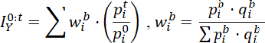

Coverage and sources of data:
Monthly wage rate data are collected from 64 districts of the country on monthly basis. Wage rates of the day labourers in regards to (i) without food (ii) with food are collected by 64 district statistical offices, BBS.

Table: 2.1 Wage Rate Index by Sectors: National (Base Index: 2021-22=100)

Sector | 2021-22 | 2022-23 | 2023-24 | May’24 | Jun’24 | Jul’24
1 | 2 | 3 | 4 | 5 | 6 | 7
General | 191.80 | 205.30 | 115.33 | 118.59 | 118.87 | 119.13
percentage change (Point to Point) | 6.06 | 7.04 | 7.74 | 7.88 | 7.95 | 7.93
percentage change(over previous  month) |  |  |  | 0.32 | 0.23 | 0.22
1. Agriculture | 192.21 | 205.69 | 115.66 | 119.05 | 119.21 | 119.45
percentage change (Point to Point) | 6.10 | 7.01 | 8.08 | 8.29 | 8.33 | 8.21
percentage change(over previous  month) |  |  |  | 0.30 | 0.13 | 0.20
I. Agriculture | 192.39 | 205.98 | 115.81 | 119.31 | 119.44 | 119.51
percentage change (Point to Point) | 6.16 | 7.06 | 8.17 | 8.45 | 8.47 | 8.28
percentage change(over previous  month) |  |  |  | 0.31 | 0.10 | 0.06
II. Fish | 183.06 | 191.07 | 113.09 | 114.73 | 115.35 | 118.40
percentage change (Point to Point) | 2.95 | 4.37 | 8.35 | 8.53 | 8.62 | 7.07
percentage change(over previous  month) |  |  |  | 0.16 | 0.54 | 2.64
2. Industry | 187.83 | 201.01 | 114.72 | 117.76 | 118.14 | 118.40
percentage change (Point to Point) | 5.85 | 6.97 | 7.24 | 7.35 | 7.42 | 7.52
percentage change(over previous  month) |  |  |  | 0.33 | 0.33 | 0.22
I. Construction | 174.62 | 184.35 | 114.29 | 117.16 | 117.58 | 118.09
percentage change (Point to Point) | 4.41 | 5.57 | 8.26 | 8.75 | 8.77 | 7.45
percentage change(over previous  month) |  |  |  | 0.29 | 0.36 | 0.43
II. Production | 214.87 | 234.79 | 117.69 | 121.97 | 122.09 | 120.58
percentage change (Point to Point) | 8.30 | 9.28 | 7.70 | 8.00 | 7.98 | 7.96
percentage change(over previous  month) |  |  |  | 0.57 | 0.10 | -1.24
3. Service | 199.42 | 212.23 | 116.22 | 119.73 | 120.15 | 120.53
percentage change (Point to Point) | 6.32 | 7.31 | 8.29 | 8.49 | 8.50 | 8.27
percentage change(over previous  month) |  |  |  | 0.44 | 0.35 | 0.32

Figure: 2.1 Figure: 2.2
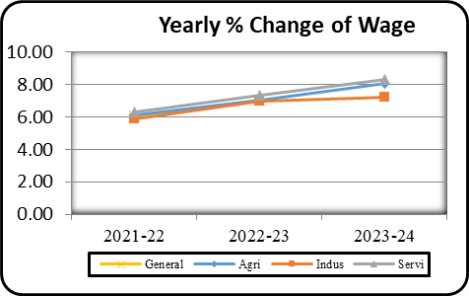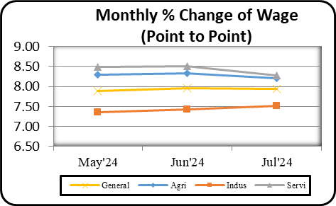

Table: 2.2 Wage Rate Index by Sectors: Dhaka Division (Base Index: 2021-22=100)

Sector | 2021-22 | 2022-23 | 2023-24 | May’24 | Jun’24 | Jul’24
1 | 2 | 3 | 4 | 5 | 6 | 7
General | 189.42 | 199.93 | 112.92 | 115.92 | 116.18 | 115.78
percentage change (Point to  Point) | 5.25 | 5.54 | 6.98 | 7.43 | 7.52 | 7.79
percentage change(over  previous month) |  |  |  | 0.29 | 0.23 | -0.34
1. Agriculture | 190.78 | 201.30 | 112.51 | 115.93 | 116.05 | 114.52
percentage change (Point to  Point) | 5.11 | 5.51 | 6.60 | 7.29 | 7.30 | 8.14
percentage change(over  previous month) |  |  |  | 0.33 | 0.10 | -1.32
I. Agriculture | 190.80 | 201.36 | 112.50 | 115.93 | 116.05 | 114.49
percentage change (Point to  Point) | 5.13 | 5.53 | 6.58 | 7.26 | 7.28 | 8.14
percentage change(over  previous month) |  |  |  | 0.33 | 0.10 | -1.34
II. Fish | 187.35 | 193.85 | 113.66 | 115.04 | 115.20 | 119.95
percentage change (Point to  Point) | 2.74 | 3.47 | 9.85 | 10.05 | 10.02 | 8.15
percentage change(over  previous month) |  |  |  | 0.12 | 0.13 | 4.13
2. Industry | 182.93 | 193.18 | 113.41 | 116.11 | 116.46 | 116.82
percentage change (Point to  Point) | 5.17 | 5.60 | 7.39 | 7.85 | 7.91 | 7.49
percentage change(over  previous month) |  |  |  | 0.24 | 0.30 | 0.30
I. Construction | 173.84 | 181.65 | 113.12 | 115.77 | 116.14 | 116.44
percentage change (Point to  Point) | 3.86 | 4.50 | 8.24 | 8.89 | 8.90 | 7.43
percentage change(over  previous month) |  |  |  | 0.25 | 0.32 | 0.26
II. Production | 202.14 | 217.53 | 115.97 | 119.11 | 119.27 | 120.14
percentage change (Point to  Point) | 7.63 | 7.63 | 7.76 | 8.19 | 8.20 | 8.02
percentage change(over  previous month) |  |  |  | 0.21 | 0.14 | 0.72
3. Service | 200.28 | 211.37 | 111.75 | 115.05 | 115.27 | 114.15
percentage change (Point to  Point) | 6.00 | 5.54 | 5.87 | 6.74 | 6.77 | 8.36
percentage change(over  previous month) |  |  |  | 0.39 | 0.19 | -0.97

Figure: 2.3 Figure: 2.4
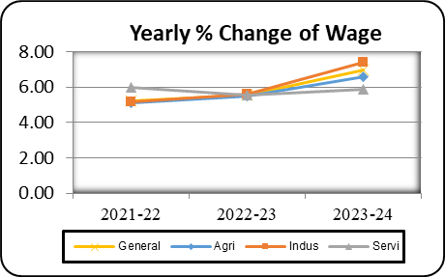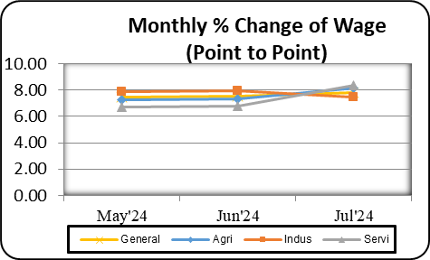

Table: 2.3 Wage Rate Index by Sectors: Chattogram Division (Base Index: 2021-22=100)

Sector | 2021-22 | 2022-23 | 2023-24 | May’24 | Jun’24 | Jul’24
1 | 2 | 3 | 4 | 5 | 6 | 7
General | 189.51 | 202.76 | 113.92 | 116.91 | 117.40 | 117.16
percentage change (Point to Point) | 6.10 | 6.99 | 6.48 | 6.53 | 6.62 | 7.41
percentagechange(over previous  month) |  |  |  | 0.37 | 0.41 | -0.20
1. Agriculture | 190.56 | 202.96 | 113.08 | 116.14 | 116.43 | 116.15
percentage change (Point to Point) | 6.23 | 6.51 | 6.16 | 6.37 | 6.46 | 7.95
Percentage change (over previous  month) |  |  |  | 0.38 | 0.25 | -0.23
I. Agriculture | 190.76 | 203.31 | 113.32 | 116.98 | 117.12 | 115.54
percentage change (Point to Point) | 6.34 | 6.59 | 6.30 | 7.01 | 6.98 | 8.35
percentage change (over previous  month) |  |  |  | 0.47 | 0.12 | -1.35
II. Fish | 185.39 | 193.62 | 112.47 | 114.03 | 114.68 | 117.69
percentage change (Point to Point) | 3.38 | 4.44 | 7.69 | 7.97 | 7.92 | 6.98
percentage change (over previous  month) |  |  |  | 0.14 | 0.57 | 2.62
2. Industry | 184.54 | 198.01 | 114.28 | 117.04 | 117.55 | 117.54
percentage change (Point to Point) | 5.59 | 7.30 | 6.51 | 6.66 | 6.70 | 6.89
percentage change (over previous  month) |  |  |  | 0.32 | 0.44 | -0.01
I. Construction | 182.46 | 195.63 | 114.18 | 116.88 | 117.40 | 117.41
percentage change (Point to Point) | 5.51 | 7.23 | 6.49 | 6.83 | 6.84 | 6.81
percentage hange(over previous  month) |  |  |  | 0.31 | 0.44 | 0.01
II. Production | 192.12 | 206.68 | 116.37 | 120.36 | 120.70 | 120.18
percentage change (Point to Point) | 5.78 | 7.57 | 8.16 | 8.58 | 8.59 | 8.39
Percentage change (over previous  month) |  |  |  | 0.48 | 0.29 | -0.43
3. Service | 194.39 | 210.68 | 115.12 | 119.07 | 120.10 | 118.79
percentage change (Point to Point) | 6.46 | 8.37 | 6.22 | 6.31 | 6.34 | 8.26
percentage change (over previous  month) |  |  |  | 0.64 | 0.87 | -1.10

Figure: 2.5 Figure: 2.6
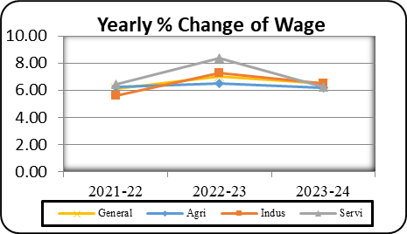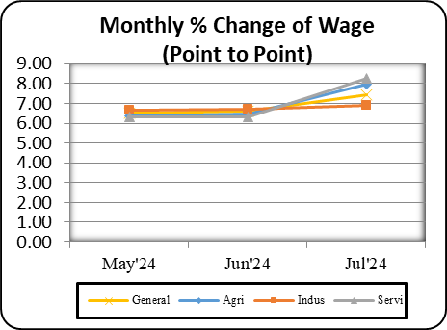

Table: 2.4 Wage Rate Index by Sectors: Rajshahi Division (Base Index: 2021-22=100)

Sector | 2021-22 | 2022-23 | 2023-24 | May’24 | Jun’24 | Jul’24
1 | 2 | 3 | 4 | 5 | 6 | 7
General | 191.24 | 204.22 | 114.45 | 117.64 | 117.86 | 118.61
percentage change (Point to Point) | 5.88 | 6.78 | 7.18 | 7.27 | 7.34 | 7.99
percentage change(over previous  month) |  |  |  | 0.32 | 0.19 | 0.64
1. Agriculture | 191.41 | 203.89 | 113.68 | 116.82 | 116.92 | 117.97
percentage change (Point to Point) | 5.71 | 6.52 | 6.72 | 6.83 | 6.84 | 8.15
percentage change(over previous  month) |  |  |  | 0.33 | 0.09 | 0.90
I. Agriculture | 191.42 | 203.91 | 113.68 | 116.86 | 116.96 | 117.91
percentage change (Point to Point) | 5.72 | 6.52 | 6.71 | 6.86 | 6.87 | 8.17
percentage change(over previous  month) |  |  |  | 0.34 | 0.08 | 0.82
II. Fish | 187.79 | 197.51 | 113.68 | 115.29 | 115.75 | 119.70
percentage change (Point to Point) | 3.48 | 5.17 | 8.10 | 7.97 | 7.98 | 7.50
percentage change(over previous  month) |  |  |  | 0.16 | 0.40 | 3.41
2. Industry | 188.50 | 202.06 | 114.87 | 117.99 | 118.36 | 118.64
percentage change (Point to Point) | 6.50 | 7.20 | 7.16 | 7.44 | 7.49 | 7.68
percentage change(over previous  month) |  |  |  | 0.27 | 0.31 | 0.24
I. Construction | 169.15 | 178.01 | 113.95 | 116.85 | 117.36 | 118.30
percentage change (Point to Point) | 3.51 | 5.23 | 8.28 | 8.47 | 8.42 | 7.71
percentage change(over previous  month) |  |  |  | 0.25 | 0.44 | 0.80
II. Production | 207.50 | 225.66 | 116.49 | 120.31 | 120.38 | 119.33
percentage change (Point to Point) | 9.01 | 8.79 | 7.33 | 7.90 | 7.87 | 7.62
percentage change(over previous  month) |  |  |  | 0.30 | 0.06 | -0.87
3. Service | 198.39 | 214.96 | 117.17 | 120.90 | 121.17 | 122.18
percentage change (Point to Point) | 5.75 | 8.33 | 8.16 | 7.52 | 7.54 | 8.37
percentage change(over previous  month) |  |  |  | 0.46 | 0.22 | 0.84

Figure: 2.7 Figure: 2.8
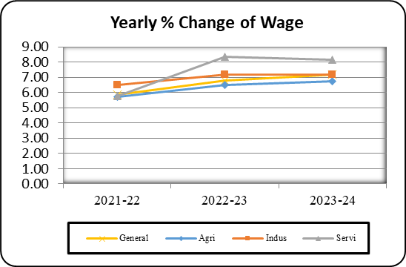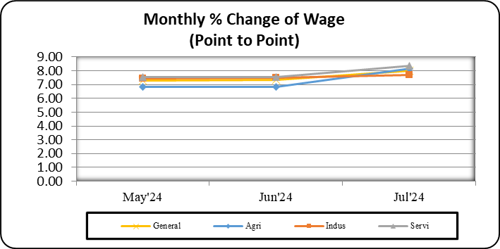

Table: 2.5 Wage Rate Index by Sectors: Rangpur Division (Base Index: 2021-22=100)

Sector | 2021-22 | 2022-23 | 2023-24 | May’24 | Jun’24 | Jul’24
1 | 2 | 3 | 4 | 5 | 6 | 7
General | 203.98 | 226.40 | 120.92 | 124.90 | 125.06 | 125.52
percentage change (Point to Point) | 8.14 | 10.98 | 8.98 | 8.22 | 8.24 | 8.51
percentage change(over previous  month) |  |  |  | 0.32 | 0.12 | 0.37
1. Agriculture | 200.68 | 222.67 | 120.72 | 124.65 | 124.75 | 125.18
percentage change (Point to Point) | 7.87 | 10.95 | 8.83 | 8.22 | 8.22 | 8.54
percentage change(over previous  month) |  |  |  | 0.23 | 0.08 | 0.34
I. Agriculture | 200.72 | 222.73 | 120.73 | 124.67 | 124.77 | 125.18
percentage change (Point to Point) | 7.89 | 10.96 | 8.83 | 8.21 | 8.21 | 8.54
percentage change(over previous  month) |  |  |  | 0.23 | 0.08 | 0.33
II. Fish | 180.08 | 189.84 | 115.32 | 116.91 | 117.06 | 121.74
percentage change (Point to Point) | 3.07 | 5.42 | 9.40 | 9.08 | 9.10 | 7.93
percentage change(over previous  month) |  |  |  | 0.13 | 0.12 | 4.00
2. Industry | 212.63 | 234.37 | 120.28 | 124.33 | 124.61 | 125.00
percentage change (Point to Point) | 8.76 | 10.21 | 9.15 | 8.17 | 8.17 | 8.44
percentage change(over previous  month) |  |  |  | 0.58 | 0.22 | 0.31
I. Construction | 174.10 | 186.69 | 119.79 | 123.08 | 123.42 | 125.17
percentage change (Point to Point) | 4.48 | 7.22 | 11.72 | 11.36 | 11.37 | 8.56
percentage change(over previous  month) |  |  |  | 0.35 | 0.27 | 1.42
II. Production | 264.36 | 300.82 | 122.46 | 129.83 | 129.87 | 124.27
percentage change (Point to Point) | 11.41 | 13.75 | 7.63 | 7.33 | 7.34 | 7.92
percentage change(over previous  month) |  |  |  | 1.56 | 0.03 | -4.31
3. Service | 226.52 | 259.15 | 125.08 | 129.35 | 129.68 | 130.76
percentage change (Point to Point) | 10.00 | 14.37 | 9.44 | 7.29 | 7.34 | 8.38
percentage change(over previous month) |  |  |  | 0.41 | 0.26 | 0.83

Figure: 2.9 Figure: 2.10
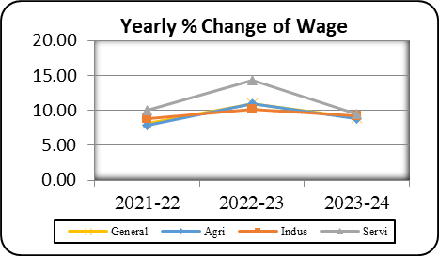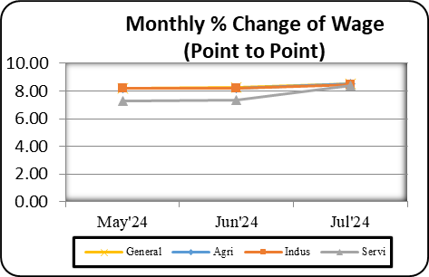

Table: 2.6 Wage Rate Index by Sectors: Khulna Division (Base Index: 2021-22=100)

Sector | 2021-22 | 2022-23 | 2023-24 | May’24 | Jun’24 | Jul’24
1 | 2 | 3 | 4 | 5 | 6 | 7
General | 191.40 | 204.62 | 114.63 | 117.87 | 118.11 | 118.30
percentage change (Point to Point) | 6.10 | 6.90 | 7.22 | 7.34 | 7.42 | 7.82
percentage change(over previous  month) |  |  |  | 0.30 | 0.21 | 0.16
1. Agriculture | 193.42 | 206.30 | 114.43 | 117.69 | 117.78 | 118.03
percentage change (Point to Point) | 6.29 | 6.65 | 7.28 | 7.47 | 7.49 | 7.99
percentage change(over previous  month) |  |  |  | 0.28 | 0.08 | 0.21
I. Agriculture | 193.95 | 207.06 | 114.41 | 117.75 | 117.82 | 117.92
percentage change (Point to Point) | 6.41 | 6.72 | 7.19 | 7.41 | 7.43 | 8.00
percentage change(over previous  month) |  |  |  | 0.29 | 0.06 | 0.08
II. Fish | 178.56 | 185.07 | 114.82 | 116.33 | 116.86 | 120.79
percentage change (Point to Point) | 2.82 | 4.53 | 9.85 | 9.80 | 9.81 | 7.56
percentage change(over previous  month) |  |  |  | 0.12 | 0.45 | 3.36
2. Industry | 180.18 | 192.09 | 113.83 | 116.95 | 117.36 | 117.32
percentage change (Point to Point) | 4.94 | 6.60 | 6.77 | 6.98 | 7.01 | 7.56
percentage change(over previous  month) |  |  |  | 0.29 | 0.35 | -0.03
I. Construction | 171.72 | 178.81 | 113.27 | 116.21 | 116.64 | 116.83
percentage change (Point to Point) | 4.12 | 5.49 | 7.36 | 7.70 | 7.70 | 7.37
percentage change(over previous  month) |  |  |  | 0.25 | 0.36 | 0.17
II. Production | 222.02 | 244.03 | 119.48 | 124.43 | 124.67 | 122.26
percentage change (Point to Point) | 7.44 | 9.17 | 8.68 | 9.57 | 9.59 | 9.38
percentage change(over previous  month) |  |  |  | 0.66 | 0.19 | -1.94
3. Service | 203.92 | 223.51 | 118.16 | 121.70 | 122.13 | 122.81
percentage change (Point to Point) | 7.37 | 9.64 | 7.82 | 7.36 | 7.37 | 7.89
percentage change(over previous  month) |  |  |  | 0.44 | 0.36 | 0.56

Figure: 2.11 Figure: 2.12
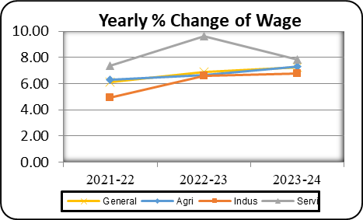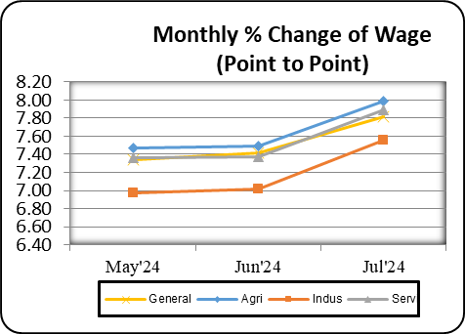

Table: 2.7 Wage Rate Index by Sectors: Barishal Division (Base Index: 2021-22=100)

Sector | 2021-22 | 2022-23 | 2023-24 | May’24 | Jun’24 | Jul’24
1 | 2 | 3 | 4 | 5 | 6 | 7
General | 193.01 | 208.20 | 123.04 | 118.52 | 118.95 | 119.43
percentage change (Point to Point) | 6.57 | 7.87 | 7.07 | 6.98 | 7.05 | 7.60
percentage change(over previous  month) |  |  |  | 0.39 | 0.36 | 0.41
1. Agriculture | 196.65 | 211.56 | 122.33 | 117.24 | 117.53 | 118.53
percentage change (Point to Point) | 6.37 | 7.59 | 6.44 | 6.20 | 6.26 | 7.40
percentage change(over previous  month) |  |  |  | 0.29 | 0.25 | 0.85
I. Agriculture | 197.05 | 212.26 | 122.69 | 117.93 | 118.03 | 118.60
percentage change (Point to Point) | 6.55 | 7.72 | 6.59 | 6.64 | 6.55 | 7.68
percentage change(over previous  month) |  |  |  | 0.32 | 0.08 | 0.48
II. Fish | 188.66 | 197.75 | 120.43 | 115.54 | 116.30 | 118.37
percentage change (Point to Point) | 2.75 | 4.82 | 8.15 | 8.51 | 8.42 | 6.72
percentage change(over previous  month) |  |  |  | 0.23 | 0.66 | 1.78
2. Industry | 177.49 | 191.23 | 121.92 | 118.92 | 119.38 | 119.43
percentage change (Point to Point) | 5.96 | 7.74 | 7.38 | 7.53 | 7.55 | 7.69
percentage change(over previous  month) |  |  |  | 0.37 | 0.38 | 0.05
I. Construction | 170.99 | 184.04 | 121.28 | 118.84 | 119.29 | 119.40
percentage change (Point to Point) | 6.02 | 7.80 | 7.42 | 7.69 | 7.68 | 7.66
percentage change(over previous  month) |  |  |  | 0.36 | 0.38 | 0.09
II. Production | 210.17 | 227.41 | 126.68 | 121.89 | 122.21 | 120.62
percentage change (Point to Point) | 5.74 | 8.20 | 8.69 | 9.21 | 9.23 | 8.55
percentage change(over previous  month) |  |  |  | 0.80 | 0.27 | -1.30
3. Service | 207.07 | 227.66 | 127.42 | 121.55 | 122.46 | 123.31
percentage change (Point to Point) | 8.91 | 9.65 | 8.09 | 7.34 | 7.37 | 7.96
percentage change(over previous  month) |  |  |  | 0.89 | 0.75 | 0.69

Figure: 2.13 Figure: 2.14
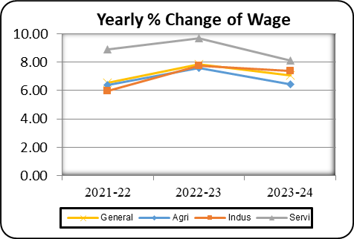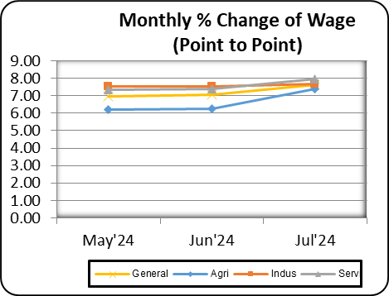

Table: 2.8 Wage Rate Index by Sectors: Sylhet Division (Base Index: 2021-22=100)

Sector | 2021-22 | 2022-23 | 2023-24 | May’24 | Jun’24 | Jul’24
1 | 2 | 3 | 4 | 5 | 6 | 7
General | 190.36 | 202.88 | 113.43 | 116.42 | 116.64 | 117.59
percentage change (Point to Point) | 5.70 | 6.57 | 6.43 | 6.53 | 6.62 | 8.01
percentage change (over previous  month) |  |  |  | 0.18 | 0.19 | 0.81
1. Agriculture | 190.93 | 203.72 | 114.03 | 117.09 | 117.17 | 117.70
percentage change (Point to Point) | 5.87 | 6.69 | 6.86 | 7.02 | 7.03 | 7.90
percentage change (over previous  month) |  |  |  | 0.21 | 0.06 | 0.45
I. Agriculture | 191.05 | 203.93 | 114.03 | 117.10 | 117.17 | 117.69
percentage change (Point to Point) | 5.93 | 6.74 | 6.82 | 6.96 | 6.98 | 7.90
percentage change (over previous  month |  |  |  | 0.21 | 0.06 | 0.44
II. Fish | 183.49 | 190.48 | 114.20 | 115.64 | 115.72 | 120.68
percentage change (Point to Point) | 2.53 | 3.81 | 10.01 | 10.03 | 10.05 | 8.03
percentage change (over previous  month |  |  |  | 0.15 | 0.07 | 4.29
2. Industry | 184.34 | 194.88 | 112.88 | 115.65 | 116.06 | 117.23
percentage change (Point to Point) | 4.67 | 5.71 | 6.77 | 6.71 | 6.73 | 7.76
percentage change (over previous  month |  |  |  | 0.17 | 0.35 | 1.01
I. Construction | 181.68 | 190.88 | 112.82 | 115.57 | 115.97 | 117.23
percentage change (Point to Point) | 4.64 | 5.07 | 7.38 | 7.90 | 7.89 | 7.78
percentage change (over previous  month |  |  |  | 0.17 | 0.35 | 1.08
II. Production | 202.67 | 222.43 | 117.21 | 123.12 | 123.27 | 117.16
percentage change (Point to Point) | 4.87 | 7.90 | 6.84 | 5.87 | 5.88 | 6.33
percentage change (over previous  month) |  |  |  | 0.28 | 0.12 | -4.95
3. Service | 198.17 | 212.51 | 113.43 | 116.64 | 116.81 | 118.03
percentage change (Point to Point) | 6.28 | 7.23 | 5.77 | 6.08 | 6.09 | 8.59
percentage change (over previous  month) |  |  |  | 0.16 | 0.14 | 1.05

Figure: 2.15 Figure: 2.16
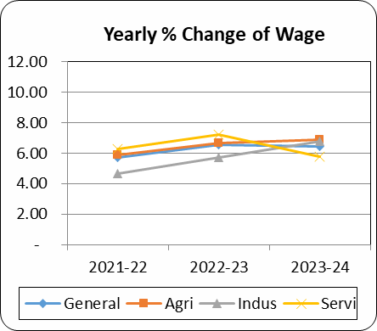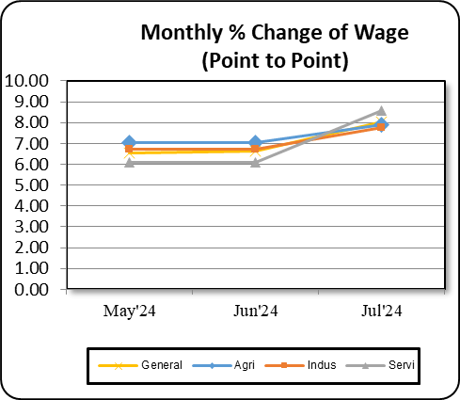

Table: 2.9 Wage Rate Index by Sectors: Mymensingh Division (Base Index: 2021-22=100)

Sector | 2021-22 | 2022-23 | 2023-24 | May’24 | Jun’24 | Jul’24
1 | 2 | 3 | 4 | 5 | 6 | 7
General | 100.00 | - | 113.14 | 116.12 | 116.48 | 116.92
percentage change (Point to Point) | - | - | - | - | - | 7.84
percentage change (over previous  month) | - | - | - | 0.45 | 0.32 | 0.37
1. Agriculture | 100.00 | - | 113.17 | 116.28 | 116.70 | 116.74
percentage change (Point to Point) | - | - | - | - | - | 8.50
percentage change (over previous  month) | - | - | - | 0.41 | 0.36 | 0.03
I. Agriculture | 100.00 | - | 113.16 | 116.28 | 116.70 | 116.71
percentage change (Point to Point) | - | - | - | - | - | 8.50
percentage change (over previous  month | - | - | - | 0.41 | 0.36 | 0.01
II. Fish | 100.00 | - | 114.24 | 116.07 | 116.31 | 119.53
percentage change (Point to Point) | - | - | - | - | - | 7.62
percentage change (over previous  month | - | - | - | 0.28 | 0.21 | 2.77
2. Industry | 100.00 | - | 113.08 | 116.11 | 116.38 | 116.69
percentage change (Point to Point) | - | - | - | - | - | 6.99
percentage change (over previous  month | - | - | - | 0.50 | 0.24 | 0.26
I. Construction | 100.00 | - | 112.94 | 115.95 | 116.23 | 116.55
percentage change (Point to Point) | - | - | - | - | - | 6.93
percentage change (over previous  month | - | - | - | 0.50 | 0.24 | 0.27
II. Production | 100.00 | - | 114.90 | 118.15 | 118.37 | 118.53
percentage change (Point to Point) | - | - | - | - | - | 7.77
percentage change (over previous  month) | - | - | - | 0.53 | 0.18 | 0.13
3. Service | 100.00 | - | 113.25 | 115.20 | 115.65 | 119.06
percentage change (Point to Point) | - | - | - | - | - | 7.78
percentage change (over previous  month) | - | - | - | 0.41 | 0.39 | 2.95
N.B.: Newly Compilation of Mymensingh Divisional Index

Table: 2.10 Historical Data (Time Series) of WRI Bangladesh (Base: 1969-70=100 to 2010-11=100)

Year | Index |  |  |  |  | Growth Rate (Point to Point)
Year | General | Manufacturing | Construct on | Agricultural | Fishery | General | Manufacturing | Construction | Agricultural | Fishery
1 | 2 | 3 | 4 | 5 | 6 | 7 | 8 | 9 | 10 | 11
Base: 1969-70=100
1974-75 | 221 | 192 | 264 | 261 | 197
1975-76 | 244 | 205 | 305 | 279 | 226 | 10.41 | 6.77 | 15.53 | 6.90 | 14.72
1976-77 | 252 | 222 | 311 | 268 | 237 | 3.28 | 8.29 | 1.97 | -3.94 | 4.87
1977-78 | 280 | 251 | 334 | 312 | 251 | 11.11 | 13.06 | 7.40 | 16.42 | 5.91
1978-79 | 346 | 318 | 414 | 370 | 311 | 23.57 | 26.69 | 23.95 | 18.59 | 23.90
1979-80 | 433 | 389 | 492 | 443 | 451 | 25.14 | 22.33 | 18.84 | 19.73 | 45.02
1980-81 | 492 | 452 | 545 | 482 | 529 | 13.63 | 16.20 | 10.77 | 8.80 | 17.29
1981-82 | 566 | 515 | 616 | 567 | 617 | 15.04 | 13.94 | 13.03 | 17.63 | 16.64
1982-83 | 598 | 558 | 677 | 558 | 639 | 5.65 | 8.35 | 9.90 | -1.59 | 3.57
1983-84 | 684 | 720 | 754 | 572 | 654 | 14.38 | 29.03 | 11.37 | 2.51 | 2.35
1984-85 | 734 | 776 | 775 | 642 | 702 | 7.31 | 7.78 | 2.79 | 12.24 | 7.34
1985-86 | 895 | 958 | 938 | 767 | 856 | 21.93 | 23.45 | 21.03 | 19.47 | 21.94
1986-87 | 1085 | 1154 | 1122 | 941 | 1054 | 21.23 | 20.46 | 19.62 | 22.69 | 23.13
1987-88 | 1201 | 1220 | 1326 | 1049 | 1189 | 10.69 | 5.72 | 18.18 | 11.48 | 12.81
1988-89 | 1288 | 1325 | 1452 | 1115 | 1225 | 7.24 | 8.61 | 9.50 | 6.29 | 3.03
1989-90 | 1426 | 1502 | 1475 | 1245 | 1403 | 10.71 | 13.36 | 1.58 | 11.66 | 14.53
1990-91 | 1482 | 1575 | 1487 | 1321 | 1452 | 3.93 | 4.86 | 0.81 | 6.10 | 3.49
1991-92 | 1553 | 1641 | 1512 | 1425 | 1547 | 4.79 | 4.19 | 1.68 | 7.87 | 6.54
1992-93 | 1638 | 1724 | 1579 | 1523 | 1641 | 5.47 | 5.06 | 4.43 | 6.88 | 6.08
1993-94 | 1709 | 1828 | 1598 | 1593 | 1699 | 4.33 | 6.03 | 1.20 | 4.60 | 3.53
1994-95 | 1786 | 1947 | 1613 | 1653 | 1770 | 4.51 | 6.51 | 0.94 | 3.77 | 4.18
1995-96 | 1900 | 2064 | 1754 | 1738 | 1882 | 6.38 | 6.01 | 8.74 | 5.14 | 6.33
1996-97 | 1989 | 2161 | 1848 | 1804 | 1974 | 4.68 | 4.70 | 5.36 | 3.80 | 4.89
1997-98 | 2141 | 2395 | 1990 | 1870 | 2053 | 7.64 | 10.83 | 7.68 | 3.66 | 4.00
1998-99 | 2259 | 2522 | 2163 | 1950 | 2138 | 5.51 | 5.30 | 8.69 | 4.28 | 4.14
1999-00 | 2390 | 2701 | 2286 | 2037 | 2220 | 5.80 | 7.10 | 5.69 | 4.46 | 3.84
2000-01 | 2489 | 2832 | 2356 | 2141 | 2292 | 4.14 | 4.85 | 3.06 | 5.11 | 3.24
2001-02 | 2637 | 3035 | 2444 | 2262 | 2411 | 5.95 | 7.17 | 3.74 | 5.65 | 5.19
2002-03 | 2926 | 3501 | 2624 | 2443 | 2563 | 10.96 | 15.35 | 7.36 | 8.00 | 6.30

Bangladesh Bureau of Statistics (BBS), visit www.bbs.gov.bd Page 37 of 42
Year | Index |  |  |  |  | Growth Rate (Point to Point)
Year | General | Manufacturing | Construct on | Agricultural | Fishery | General | Manufacturing | Construction | Agricultural | Fishery
1 | 2 | 3 | 4 | 5 | 6 | 7 | 8 | 9 | 10 | 11
2003-04 | 3111 | 3765 | 2669 | 2582 | 2775 | 6.32 | 7.54 | 1.71 | 5.69 | 8.27
2004-05 | 3293 | 4015 | 2758 | 2719 | 2957 | 5.85 | 6.64 | 3.33 | 5.31 | 6.56
2005-06 | 3505 | 4293 | 2889 | 2925 | 3133 | 6.44 | 6.92 | 4.75 | 7.58 | 5.95
2006-07 | 3779 | 4636 | 3135 | 3156 | 3332 | 7.82 | 7.99 | 8.52 | 7.90 | 6.35
2007-08 | 4227 | 5144 | 3505 | 3488 | 3635 | 11.85 | 10.96 | 11.80 | 10.52 | 9.09
2008-09 | 5025 | 6128 | 4262 | 4275 | 4334 | 18.88 | 19.13 | 21.60 | 22.56 | 19.23
2009-10 | 5441 | 6520 | 4633 | 4804 | 4727 | 8.28 | 6.40 | 8.70 | 12.37 | 9.07
2010-11 | 5782 | 6778 | 4983 | 5325 | 5043 | 6.27 | 3.96 | 7.55 | 10.85 | 6.69
2011-12 | 6469 | 7221 | 6583 | 6134 | 5187 | 11.88 | 6.54 | 32.11 | 15.19 | 2.86
2012-13 | 7422 | 7978 | 7684 | 7448 | 6021 | 14.73 | 10.48 | 16.73 | 21.44 | 16.08
2013-14 | 8097 | 8700 | 8238 | 8283 | 6566 | 9.10 | 9.05 | 7.20 | 11.20 | 9.06
2014-15 | 8899 | 9553 | 9004 | 9254 | 7129 | 9.90 | 9.81 | 9.31 | 11.73 | 8.57

Year | Index |  |  |  | Growth Rate (Point to Point)
Year | General | Agricultural | Industry | Service | General | Agricultural | Industry | Service
1 | 2 | 3 | 4 | 5 | 6 | 7 | 8 | 9
Base: 2010-11=100
2010-11 | 100.00 | 100.00 | 100.00 | 100.00
2011-12 | 106.24 | 105.96 | 106.92 | 106.23 | 6.24 | 5.96 | 6.92 | 6.23
2012-13 | 112.62 | 112.08 | 113.43 | 113.63 | 6.01 | 5.78 | 6.08 | 6.96
2013-14 | 118.82 | 118.44 | 119.07 | 120.16 | 5.50 | 5.68 | 4.97 | 5.75
2014-15 | 124.69 | 124.51 | 124.38 | 126.15 | 4.94 | 5.12 | 4.47 | 4.98
2015-16 | 132.81 | 132.48 | 132.02 | 136.03 | 6.52 | 6.41 | 6.16 | 7.86
2016-17 | 141.46 | 141.22 | 140.27 | 145.01 | 6.50 | 6.59 | 6.24 | 6.60
2017-18 | 150.59 | 150.27 | 149.45 | 154.44 | 6.46 | 6.41 | 6.55 | 6.51
2018-19 | 160.23 | 159.92 | 158.74 | 164.78 | 6.40 | 6.42 | 6.22 | 6.69
2019-20 | 170.39 | 170.28 | 168.24 | 175.33 | 6.35 | 6.48 | 5.99 | 6.41
2020-21 | 180.83 | 181.16 | 177.52 | 185.99 | 6.12 | 6.39 | 5.51 | 6.07
2021-22 | 191.80 | 192.21 | 187.83 | 199.42 | 6.06 | 6.10 | 5.85 | 6.32
2022-23 | 205.30 | 205.69 | 201.01 | 212.23 | 7.04 | 7.01 | 6.97 | 7.31

Year | Index |  |  |  | Growth Rate (Point to Point)
Year | General | Agricultural | Industry | Service | General | Agricultural | Industry | Service
1 | 2 | 3 | 4 | 5 | 6 | 7 | 8 | 9
Base: 2021-22 = 100
2022-23 | 107.04 | 107.01 | 106.97 | 107.32 | 7.04 | 7.01 | 6.97 | 7.31
2023-24 | 110.38 | 115.66 | 114.72 | 116.22 | 7.52 | 8.08 | 7.24 | 8.29

Chapter 3

Annex

Team of Price & Wage Statistics, BBS

SL  No. | Name, Designation and Contact | Office/Organizations
01 | Mr. Mohammed Mizanur Rahman  Director General (Addl. Secretary)  +88-02-9112589 | Bangladesh Bureau of Statistics (BBS)
02 | Mr. Md. Rafiqul Islam  Director (In charge)  +88-01712-141750 | National Accounting Wing (NAW), BBS
03 | Md. Mahbubur Rahman  Joint Director  +88-01552395315 | National Accounting Wing (NAW), BBS
04 | Mr. Mohiuddin Ahmed MPH  Deputy Director  Price & Wages Statistics Section, NAW  +88-01711-952333 | Price & Wages Statistics Section National Accounting Wing, BBS
05 | Mr. Shapon Kumar  Deputy Director  +88-01712-638975
06 | Mr. Md. Ashadur Alam Prodhan  Statistical Officer  +88-01723-596476
07 | Mr. Md. Faruk Hossain  Thana Statistician
08 | Mr. Md. Rezaul Hoque  Junior Statistical Assistant
09 | Mr. Md. Azizul Hoque  Office Assistant Cum Computer Typist
10 | Ms. Khayrunnaher  Office Assistant Cum Computer Typist
11 | Ms. Aklima Khanom  Data Entry Control Operator

References
- Monthly Release on Consumer Price Index (1974-2024), Published by Bangladesh Bureau of Statistics (BBS), Statistics and Informatics Division, Ministry of Planning.
- National Accounts Statistics (Provisional Estimates of GDP, 2022-23 and Final Estimates of GDP, 2021-22), Published by Bangladesh Bureau of Statistics (BBS), Statistics and Informatics Division, Ministry of Planning.
- The Household Income and Expenditure Survey (HIES) 2016-17, Published by Bangladesh Bureau of Statistics (BBS), Ministry of Planning.
- The Labor Force Survey (LFS) 2016-17 Published in January 2018 by Bangladesh Bureau of Statistics (BBS), Ministry of Planning.
- Sources and Methods of Indices (National Accounts Deflators): June 1997, Published by Bangladesh Bureau of Statistics (BBS), Ministry of Planning.
- Fifty Years of National Accounting of Bangladesh (1972-2022), Published by Bangladesh Bureau of Statistics (BBS), Ministry of Planning.

